

Cairns Primary School

Numeracy and Maths

Early Level Addition, Subtraction, Multiplication, Division Help sheet

Dear Parent / Carer,

During a recent consultation with parents about how we best support you, and your child with maths, it was suggested that help sheets highlighting what is taught in maths and how we do it would be helpful for parents in assisting their child with maths and numeracy.

The following Learning Help booklet is aimed at providing parents and carers with information to support their children when completing Numeracy calculations at home. We hope it will provide you with detailed steps on how to complete each calculation using the methodology that will be taught in school for Addition, Subtraction, Multiplication and Division. This will ensure that pupils receive consistency helping your child to consolidate their understanding in these areas.

Please give your comments and feedback on this booklet so we can adjust, improve and supplement it for parents.

Raising Attainment in Maths Working Party

|  |  |
| --- | --- |
| Maths Vocabulary  It is important your child knows there are lots of words and ways used to describe key maths calculations. | |
| Addition | Subtraction |
| +  add  plus  make  Find the sum of…  How many altogether?  Find the total  How many more? | -  subtract  Take away  Find the difference between  minus  How many less? |
| Multiply | Divide |
| X  multiplication  Times  Groups of  Multiples of  Repeated addition  Multiplied by  Lots of  Product | ÷  division  Share  Divided by  Divided into  Share equally  Equal groups of |

Layout

When setting out sums in a jotter it is important to only allocate one number and sign (+ and -) per box.

|  |  |  |  |  |  |  |  |  |  |  |  |  |  |  |  |
| --- | --- | --- | --- | --- | --- | --- | --- | --- | --- | --- | --- | --- | --- | --- | --- |
|  |  |  |  |  |  |  |  |  |  |  |  |  |  |  |  |
|  | 4 | + | 4 | = | 8 |  |  |  | 2 | + | 7 | = | 9 |  |  |
|  | 5 | - | 3 | = | 2 |  |  | 1 | 0 | - | 5 | = | 5 |  |  |
|  |  |  |  |  |  |  |  |  |  |  |  |  |  |  |  |
|  |  |  |  |  |  |  |  |  |  |  |  |  |  |  |  |

Before you begin always check the sign

Addition

Adding up to 20 using concrete materials (e.g. cubes, beads etc.)

Method – Use a grab and count mat (you can find this online or ask for one home from school) or alternatively draw 2 circles on a piece of paper.

1. 10 + 9 = 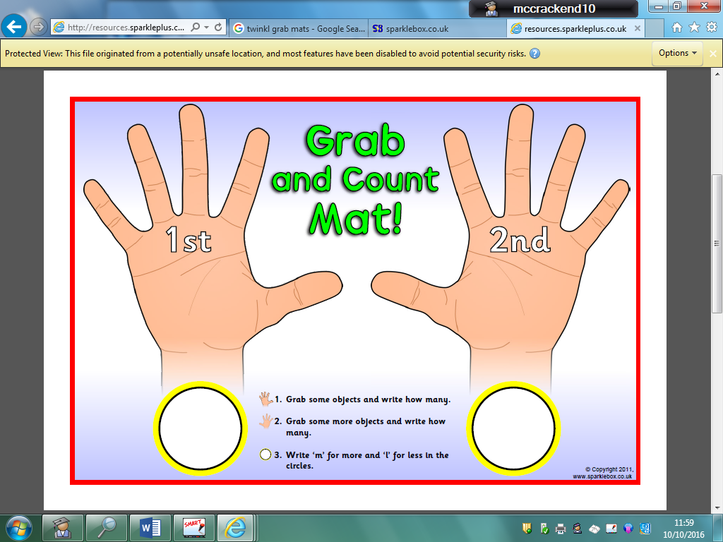
2. Check the sum. The sum is 10 + 9=.
3. Place 10 cubes in the 1st hand/circle.
4. Place 9 cubes in the 2nd hand/circle.
5. Then count all the cubes on both hands/circles up. This makes 19.
6. So the sum is 10+9=19.

Addition

Written methods – Adding up to 20 using pictures (e.g. dots)

Method –

1. 9 + 8 =

|  |
| --- |
| 9 + 8 = 17 |

1. Check the sum. The sum is 9 + 8 =.
2. Draw 9 dots with a pen/pencil under the 1st number in the sum.
3. Draw 8 dots with a pen/pencil under the 2nd number in the sum.
4. Then count all the dots under both numbers. This makes 17.
5. So the sum is 9+8=17.

Addition

Written methods – Adding up to 20 using a number line.

Method - Use a number line to 20 (you can make this yourself, find this online or get one from school).

1. 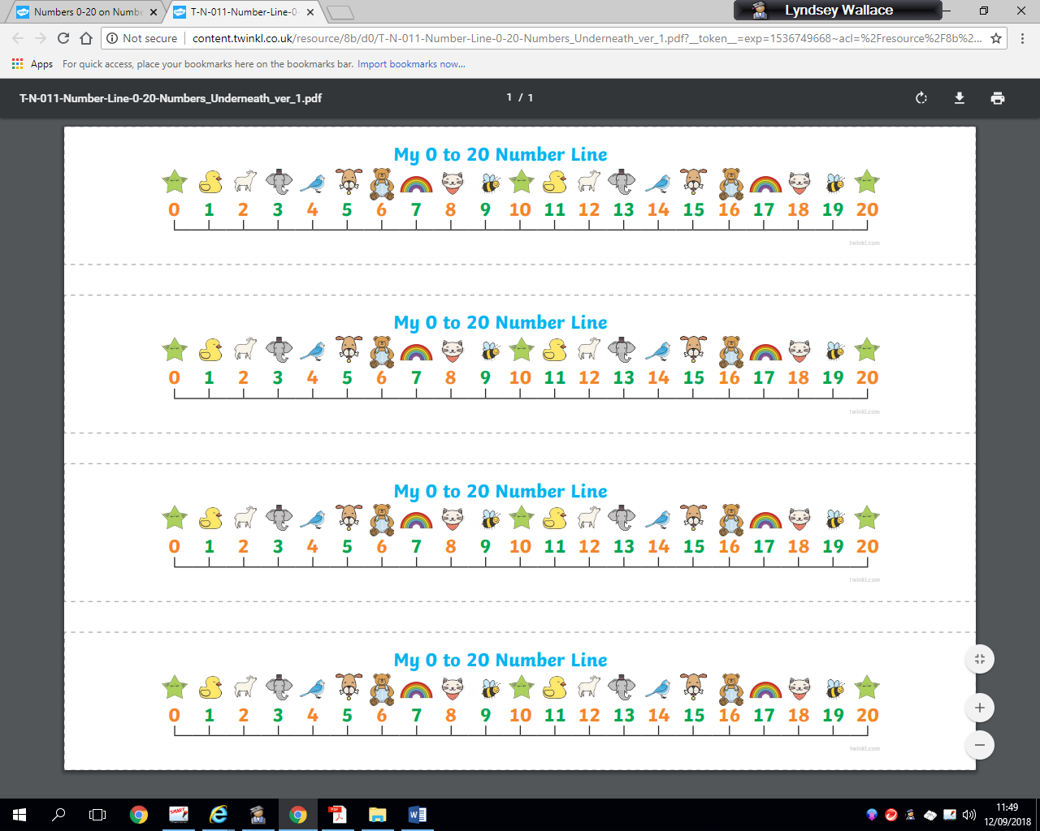11 + 6 =
2. Check the sum. It is 11 + 6 =.
3. Find the biggest number in the sum first, which is 11. Find and point to 11 on the number line.
4. Now ‘bunny hop/jump’ up the smaller number, which is 6. Move your finger up 6 places.

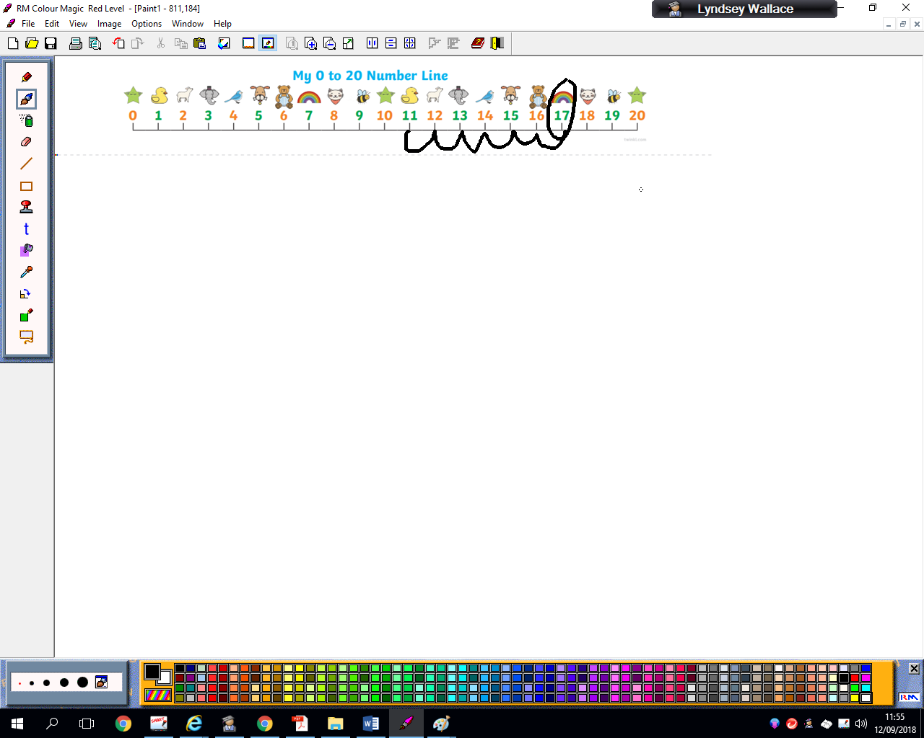

1. Check the number you finish on, it is 17.
2. So the sum is 11 + 6 = 17.

Mental Maths strategies-

Number bonds to 10 quick recall

Basic number bonds are critical foundations for maths and provide

the basis of a sound understanding of number which can be built on when learning new concepts. Playing mental maths games and answering mental arithmetic questions and repeating number bonds helps children to learn and become familiar with them. This makes progression in number work easier as the concepts get harder.

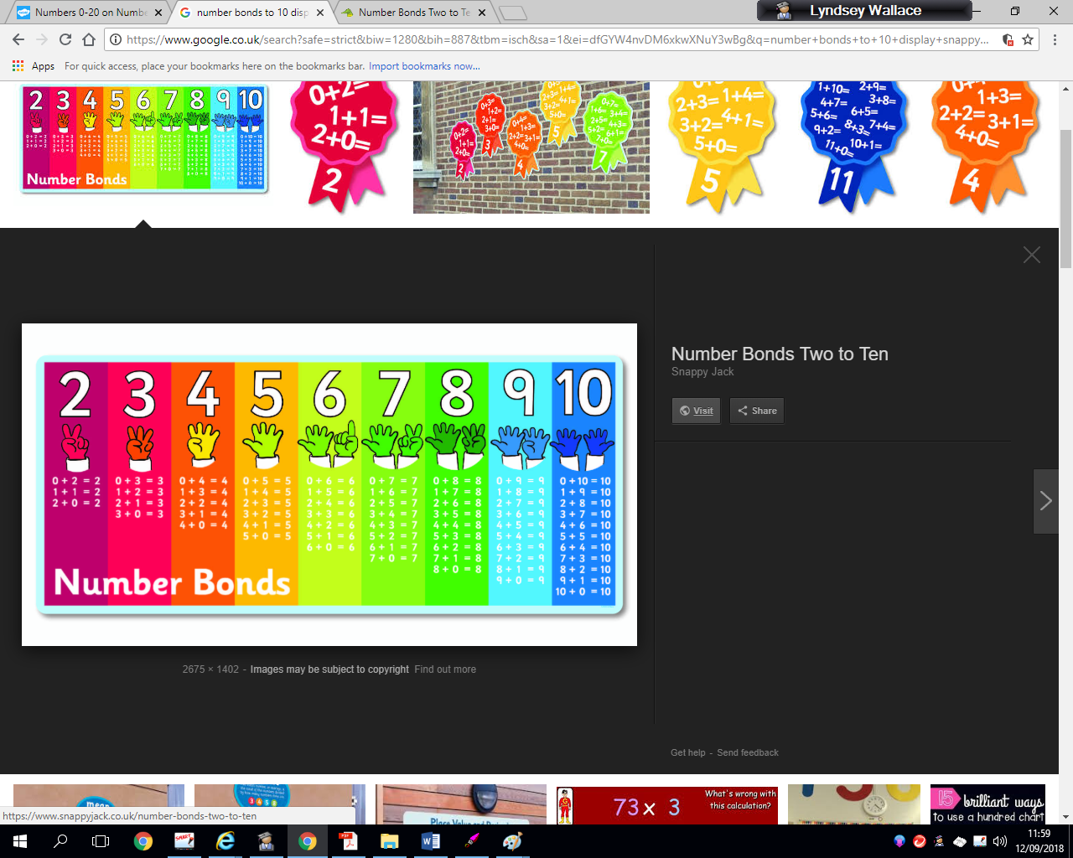



Mental maths games to support number bonds

* **Finger Speed-Sums**   
  Students meet in pairs with one hand behind their back. On the count of three, they each put forward some number of fingers. Whoever says the sum first wins. Then the pair breaks up and each person finds a new person to play with. Advanced players can use two hands instead of just one.
* **Cat and Mouse Addition:** All students have a number pinned to their backs. A cat is chosen and given a math problem to solve. The cat must chase the mice until she has caught a mouse with the correct answer on his or her back.
* **Tell me.. The number after ...**

Subtraction

Subtraction from 20 using concrete materials (e.g. cubes, beads etc.)

Method – Use a subtraction mat (you can find this online or ask for one home from school) or alternatively draw a square and a circle on a piece of paper.

1. 15-6 =

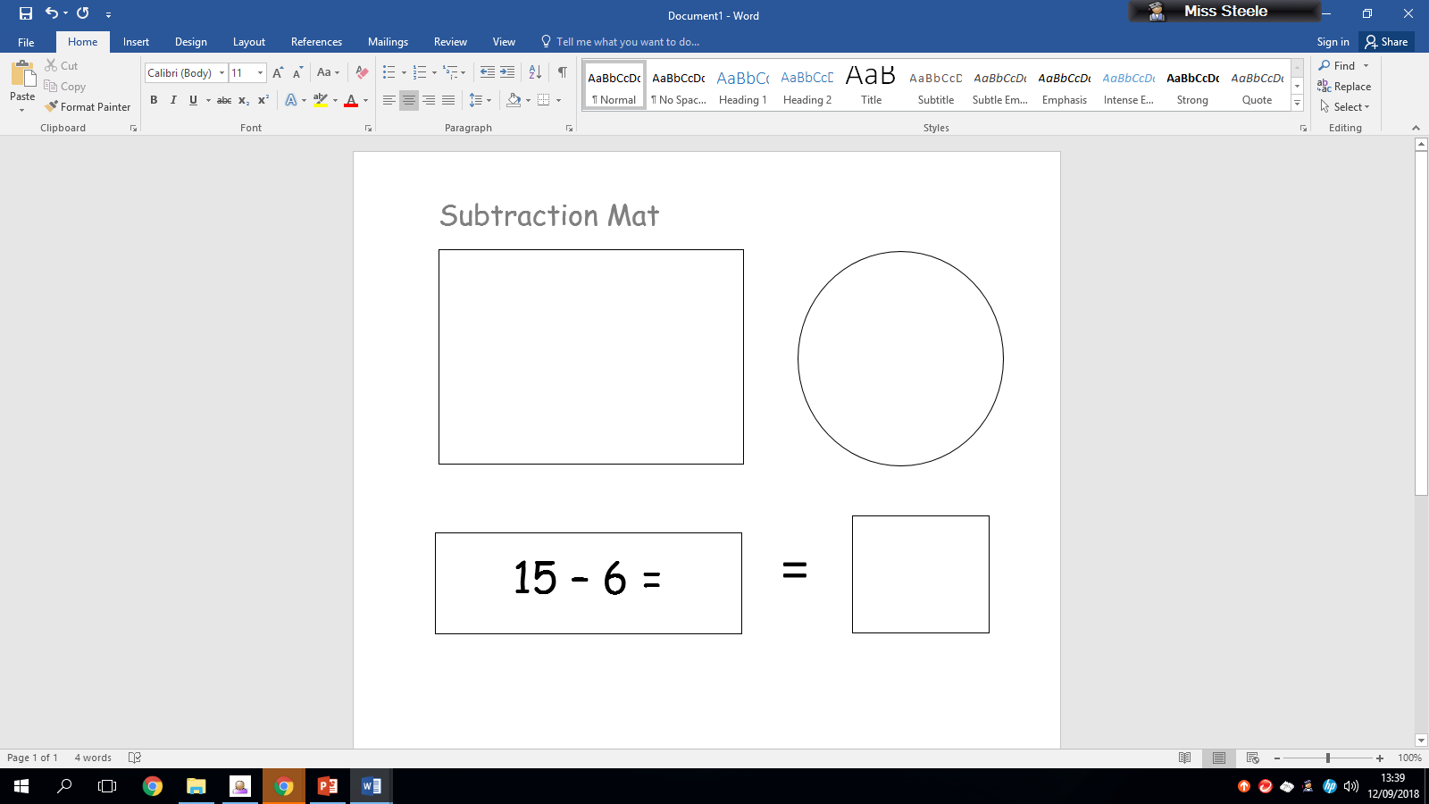

1. Check the sum. It is 15-6 =.
2. Place the 1st number of cubes in the square, this is 15.
3. Then, place the 2nd number of cubes in the circle, this is 6. So you are taking 6 cubes away from the square and placing them in the circle.
4. Now count the remaining cubes left in the square, this is 9.
5. So the sum is 15-6=9.

Subtraction from 10 using pictures (e.g. dots, animals, flowers etc).

Method –

1. 10 – 8 =

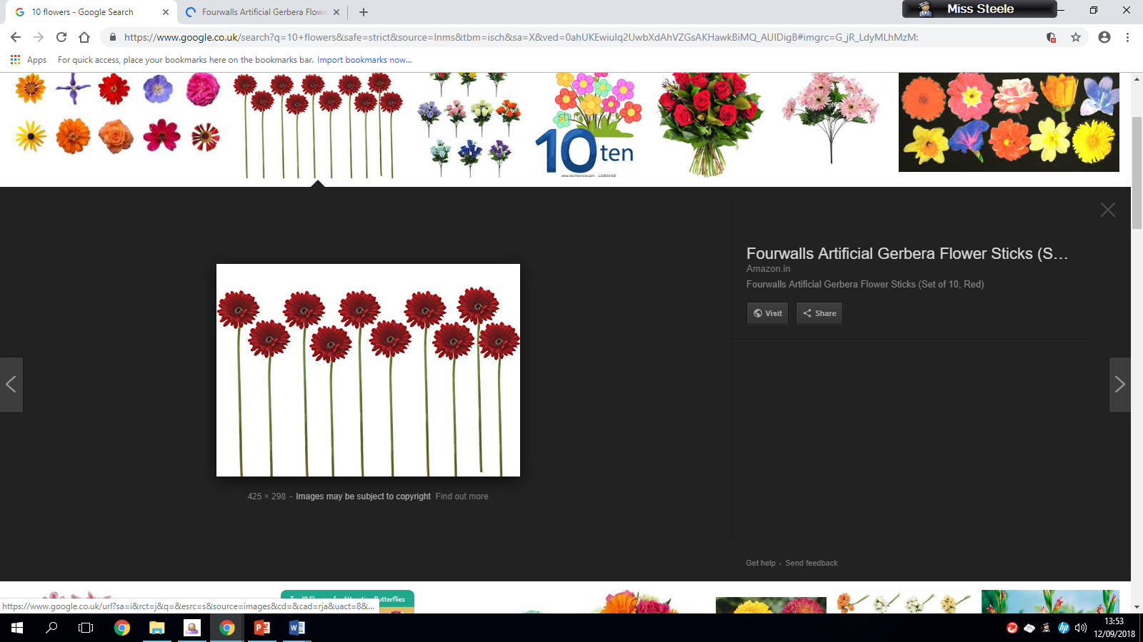

1. Check the sum, it is 10-8 =.
2. Count the objects in the picture, check it matches the 1st number in the sum, this is 10 so it does match.
3. Then use your pen/pencil to put a cross through the 2nd number in the sum, this is 8. So you cross out 8 objects in the picture.

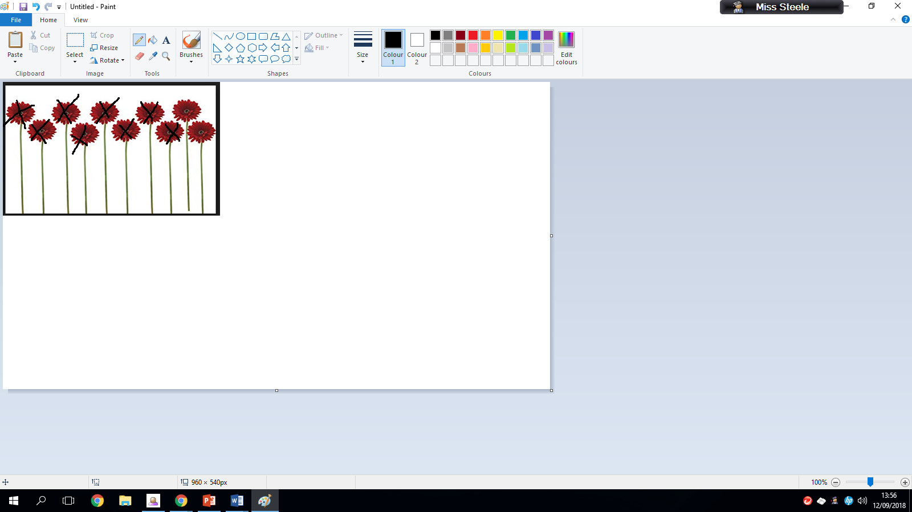

1. Count the amount of pictures that do not have a cross through them, this is 2.
2. So the sum is 10-8 = 2.

Subtraction from 20 using a number line

Method – Use a number line to 20 (you can make this yourself, find this online or get one from school).

1. 19 – 13 =
2. Check the sum, it is 19-13=.
3. Find the 1st number in the sum on the number line and place your finger on it, this is 19.
4. Then check the 2nd number in the sum, this is 13. Now ‘bunny hop/jump’ back that amount of spaces using your finger.

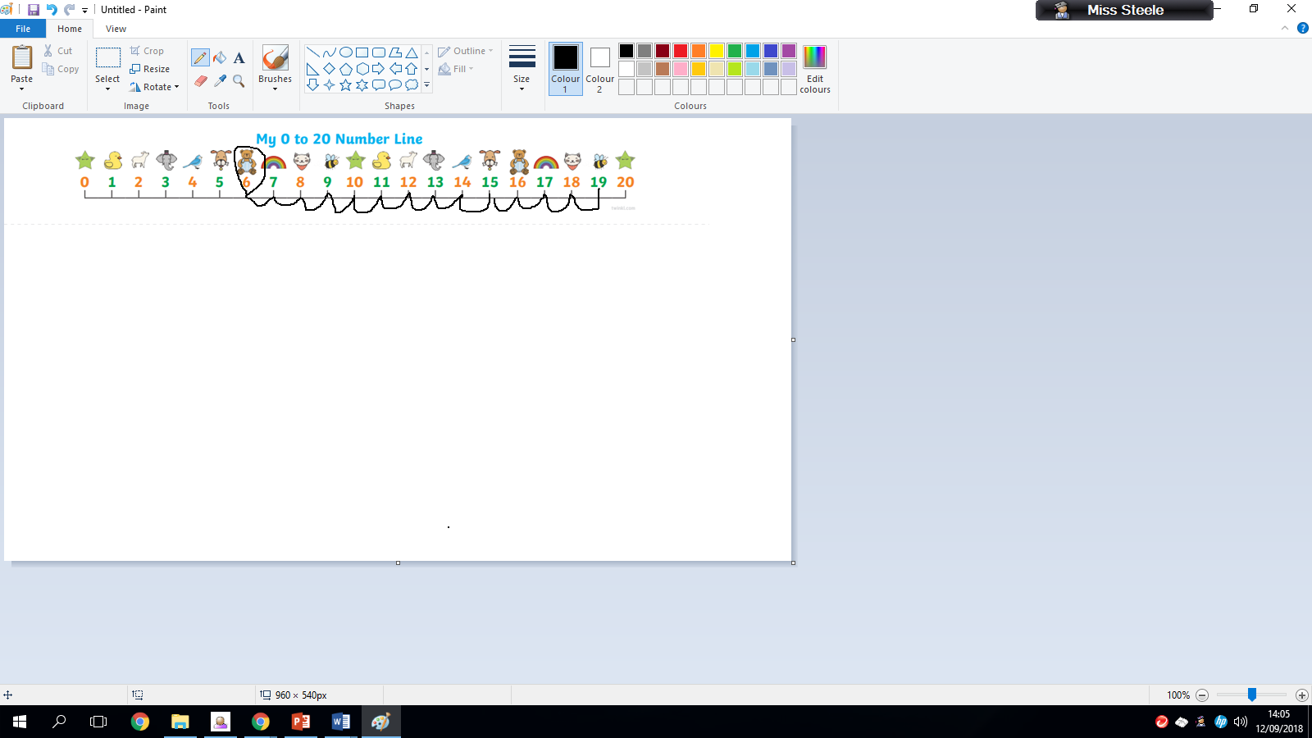

1. Check the number you finish on, it is 6.
2. So the sum is 19-13=6.

Mental Maths strategies-

Number bonds to 10 quick recall

Basic number bonds are critical foundations for maths and provide

the basis of a sound understanding of number which can be built on when learning new concepts. Playing mental maths games and answering mental arithmetic questions and repeating number bonds helps children to learn and become familiar with them. This makes progression in number work easier as the concepts get harder.

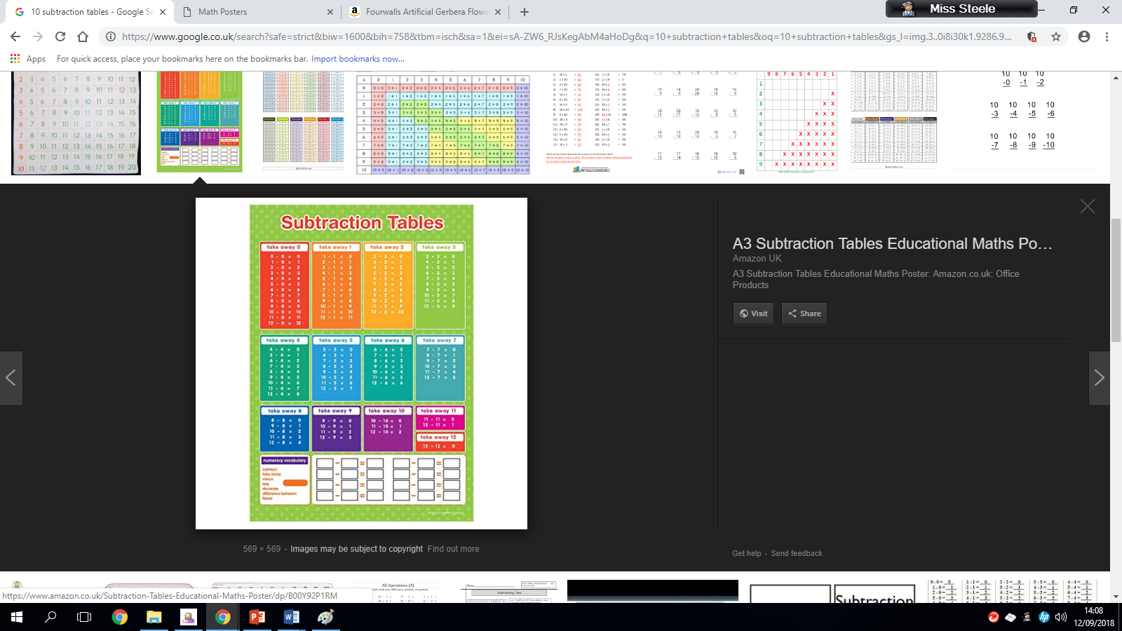

**Games to support subtraction number bonds**

* **Tell me.. The number after ... e.g 7**
* **Tell me .. The number in-between e.g. 8 and 10**

Multiplication

At Early Level the children learn the basics of multiplication through adding doubles/repeated addition. This leads on to learning their 2 times table at First Level. Children should learn their doubles to 10 by the end of first level.

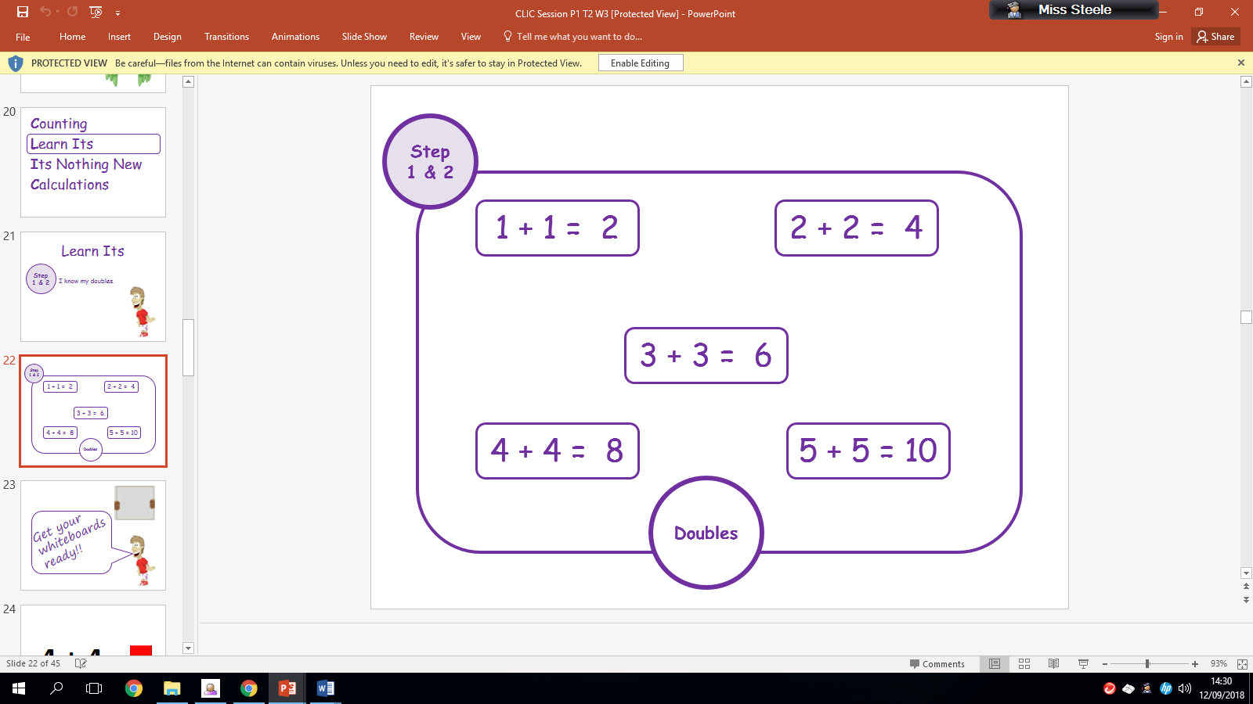

Division –

At Early level the children learn to divide out amounts by sharing equally into a given number of piles and then seeing how many there are in each pile. The children learn about halving objects and this leads on to dividing by 2 at Early Level.

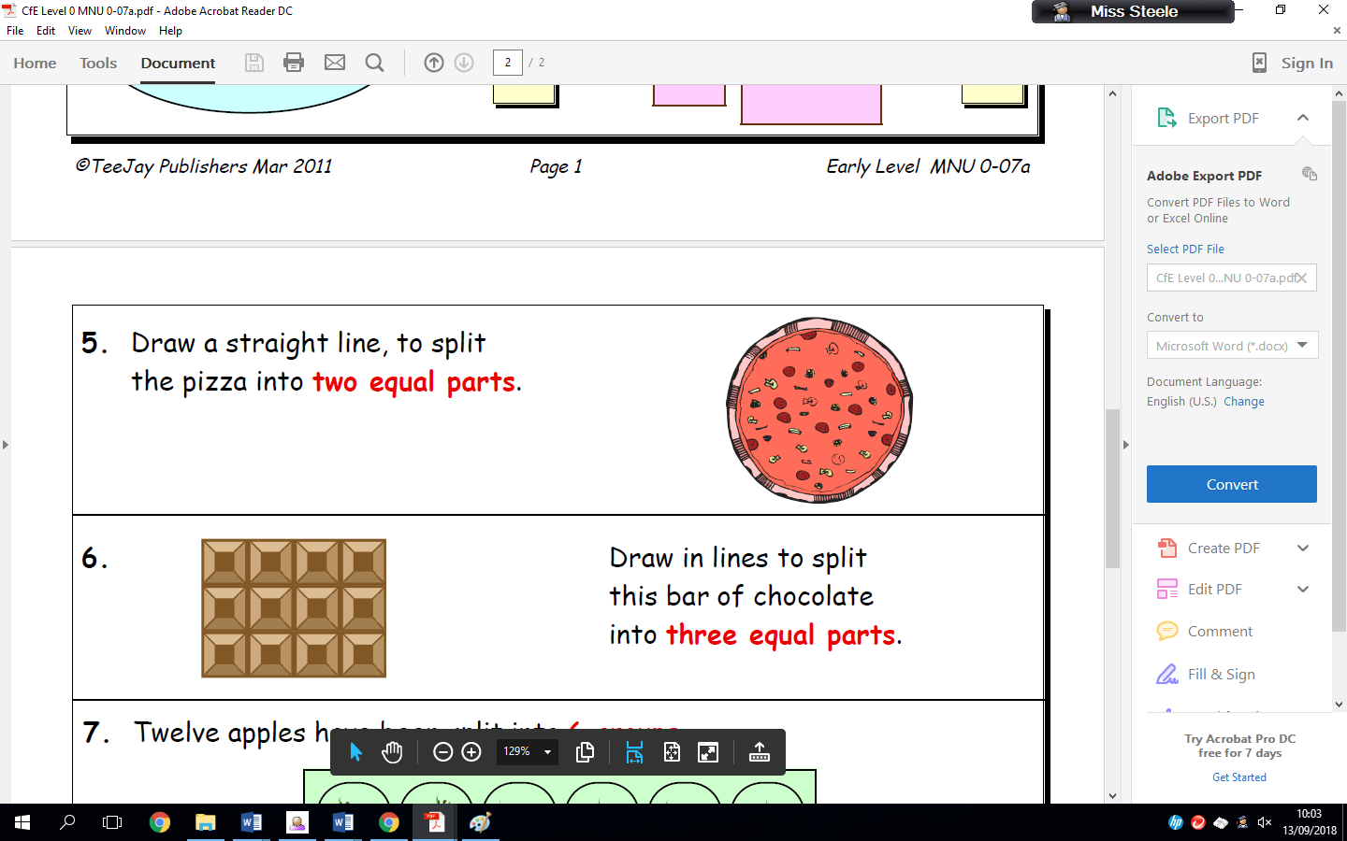

Note: If you wish to receive further information on times tables and division you can look to the First level numeracy help sheets.