

Cairns Primary School

Numeracy and Maths

First Level Help booklet for Addition, Subtraction, Multiplication and Division

Dear Parent / Carer,

During a recent consultation with parents about how we best support you, and your child with maths, it was suggested that help sheets highlighting what is taught in maths and how we do it would be helpful for parents in assisting their child with maths and numeracy.

The following Learning Help booklet is aimed at providing parents and carers with information to support their children when completing Numeracy calculations at home. We hope it will provide you with detailed steps on how to complete each calculation using the methodology that will be taught in school for Addition, Subtraction, Multiplication and Division. This will ensure that pupils receive consistency, helping your child to consolidate their understanding in these areas.

Please give your comments and feedback on this booklet so we can adjust, improve and supplement it for parents.

Raising Attainment in Maths Working Party

|  |  |
| --- | --- |
| Maths Vocabulary  It is important your child knows there are lots of words and ways used to describe key maths calculations. | |
| Addition | Subtraction |
| +  add  plus  make  Find the sum of…  How many altogether?  Find the total  How many more? | -  subtract  Take away  Find the difference between  minus  How many less? |
| Multiply | Divide |
| X  multiplication  Times  Groups of  Multiples of  Repeated addition  Multiplied by  Lots of  Product | ÷  division  Share  Divided by  Divided into  Share equally  Equal groups of |

Layout

When setting out calculations in a jotter it is important to only allocate one number per box and the sign (+ - x) should not sit under the numbers.

Addition, Subtraction and Multiplication Layout Examples:

|  |  |  |  |  |  |  |  |  |  |  |  |  |  |  |  |
| --- | --- | --- | --- | --- | --- | --- | --- | --- | --- | --- | --- | --- | --- | --- | --- |
|  |  |  |  |  |  |  |  |  |  |  |  |  |  |  |  |
|  |  | 4 | 2 |  |  |  | 5 | 7 |  |  |  | 4 | 2 |  |  |
|  | + |  | 6 |  |  | - | 2 | 3 |  |  | x |  | 6 |  |  |
|  |  | 4 | 8 |  |  |  | 3 | 4 |  |  | 2 | 5 | 2 |  |  |
|  |  |  |  |  |  |  |  |  |  |  |  | 1 |  |  |  |

Before you begin always check the sign.

Important things to remember!

For addition, subtraction and multiplication –

* always start from the furthest column on the right.
* make sure the sums are set out correctly, with each digit in its correct place value column (Th, H, T or U)

Division ‘Bus Stop’ Layout Example:

|  |  |  |  |  |  |  |  |  |  |  |  |
| --- | --- | --- | --- | --- | --- | --- | --- | --- | --- | --- | --- |
|  |  | 1 | 1 |  |  |  |  |  |  |  |  |
|  | 5 | 5 | 5 |  |  |  |  |  |  |  |  |
|  |  |  |  |  |  |  |  |  |  |  |  |
|  |  |  |  |  |  |  |  |  |  |  |  |
|  |  |  |  |  |  |  |  |  |  |  |  |

Important things to remember!

For division -

* start with the furthest column on the left (inside the ‘bus stop’)
* make sure that the number to be divided is inside the ‘bus stop’ (e.g. 55) and the number that it’s being divided by is outside (e.g. 5).

Addition

Written methods – without carrying.

Adding with Thousands (Th), Hundreds (H), Tens and Units (T, U)

|  |  |  |  |  |  |  |  |  |  |  |  |  |
| --- | --- | --- | --- | --- | --- | --- | --- | --- | --- | --- | --- | --- |
|  | A) | T | U | B) | H | T | U | C) | TH | H | T | U |
|  |  | 4 | 5 |  | 3 | 2 | 3 |  | 5 | 7 | 3 | 4 |
| ++ | + | 5 | 2 | + | 4 | 5 | 5 | + | 2 | 1 | 6 | 3 |
|  |  | 9 | 7 |  | 7 | 7 | 8 |  | 7 | 8 | 9 | 7 |
|  |  |  |  |  |  |  |  |  |  |  |  |  |
|  |  |  |  |  |  |  |  |  |  |  |  |  |
|  |  |  |  |  |  |  |  |  |  |  |  |  |
|  |  |  |  |  |  |  |  |  |  |  |  |  |

Method

Example A- 2 digits without carrying (T, U)

1. Check the sign and ask, is it addition or subtraction?
2. Start with the units’ column (U). Add the 2 numbers together. Write the answer in the units’ column.
3. Move to the tens’ column (T). Add the 2 numbers together. Write the answer in the tens column.

Example B – 3 digits without carrying (H, T, U)

1. Check the sign and ask, is it addition or subtraction?
2. Start with the units’ column (U). Add the 2 numbers together. Write the answer in the units’ column.
3. Move to the tens’ column (T). Add the 2 numbers together. Write the answer in the tens column.
4. Move to the hundreds column (H). Add the 2 numbers together. Write the answer in the hundreds column.

Example C – 4 digits without carrying (Th, H, T, U)

1. Check the sign and ask, is it addition or subtraction?
2. Start with the units’ column (U). Add the 2 numbers together. Write the answer in the units’ column.
3. Move to the tens’ column (T). Add the 2 numbers together. Write the answer in the tens column.
4. Move to the hundreds column (H). Add the 2 numbers together. Write the answer in the hundreds column.
5. Move to the Thousands column (Th). Add the 2 numbers together. Write the answer in the thousands column.

Addition

Written methods – with carrying.

Adding with Thousands (Th), Hundreds (H), Tens and Units (T, U)

|  |  |  |  |  |  |  |  |  |  |  |  |  |  |  |
| --- | --- | --- | --- | --- | --- | --- | --- | --- | --- | --- | --- | --- | --- | --- |
|  | T | U |  | H | T | U |  |  |  | Th | H | T | U |  |
|  |  | 5 |  | 8 | 4 | 5 |  |  |  | 4 | 6 | 7 | 3 |  |
| + |  | 7 | + |  | 5 | 8 |  |  | + | 4 | 3 | 3 | 8 |  |
|  | 8 | 2 |  | 9 | 0 | 3 |  |  |  | 9 | 0 | 1 | 1 |  |
|  | 1 |  |  | 1 | 1 |  |  |  |  | 1 | 1 | 1 |  |  |
|  |  |  |  |  |  |  |  |  |  |  |  |  |  |  |
|  |  |  |  |  |  |  |  |  |  |  |  |  |  |  |
|  |  |  |  |  |  |  |  |  |  |  |  |  |  |  |

Method

Example A- 2 digits with carrying (T, U)

1. Check the sign and ask, is it addition or subtraction?
2. Start with the units column **(U**). Add the 2 numbers together. Say “5 add 7 equals 12”. Place the 2 in the units column and place the 1 under the tens (T) column.
3. Move to the tens column (**T**). Add the 2 numbers together. Say “6 tens add 1 ten plus the 1 ten that was carried over equals 8 tens”. Place the 8 in the tens column.

Example B – 3 digits with carrying (H, T, U)

1. Check the sign and ask, is it addition or subtraction?
2. Start with the units’ column (**U**). Say “5 add 8 equals 13”. Place the 3 in the units column and place the 1 under the tens (T) column.
3. Move left to the tens column (**T**). Add the tens column, say “4 tens add 5 tens plus the 1 ten you carried over equals 10 tens”. Place the 0 in the tens column and the 1 under the hundreds (H) column.
4. Move left to the hundreds column. (**H**) Add the hundreds column, say ‘8 hundreds add 0 hundreds plus the 1 hundred I carried over equals 9 hundreds”. Place the 9 in the hundreds column

Example C – 4 digits with carrying (Th, H, T, U)

1. Check the sign and ask, is it addition or subtraction?
2. Start with the units’ column (**U**). Say “3 add 8 equals 11”. Place the 1 in the units column and place the 1 under the tens (T) column.
3. Move left to the tens column (**T**). Add the tens column, say “7 tens add 1 ten plus the 1 ten you carried over equals 11 tens”. Place the 1 in the tens column and the 1 under the hundreds (H) column.
4. Move left to the hundreds column (**H**). Add the hundreds column, say ‘6 hundreds add 3 hundreds plus the 1 hundred I carried over equals 10 hundreds”. Place the 0 in the hundreds column and the 1 under the thousands (Th) column.
5. Move left to the Thousands column (**Th**). Add the thousands column, say “4 thousands add 4 thousands plus the 1 thousand you carried over equals 9 thousands”. Write the number in the thousands column.



Mental Maths strategies-

Number bonds to 20 quick recall

Basic number bonds are critical foundations for maths and provide

[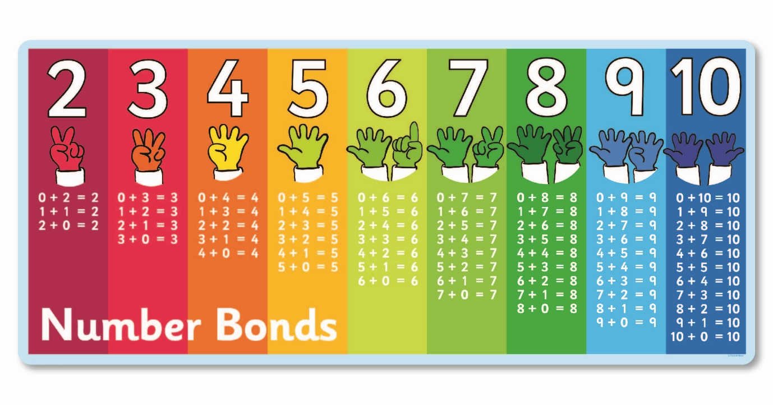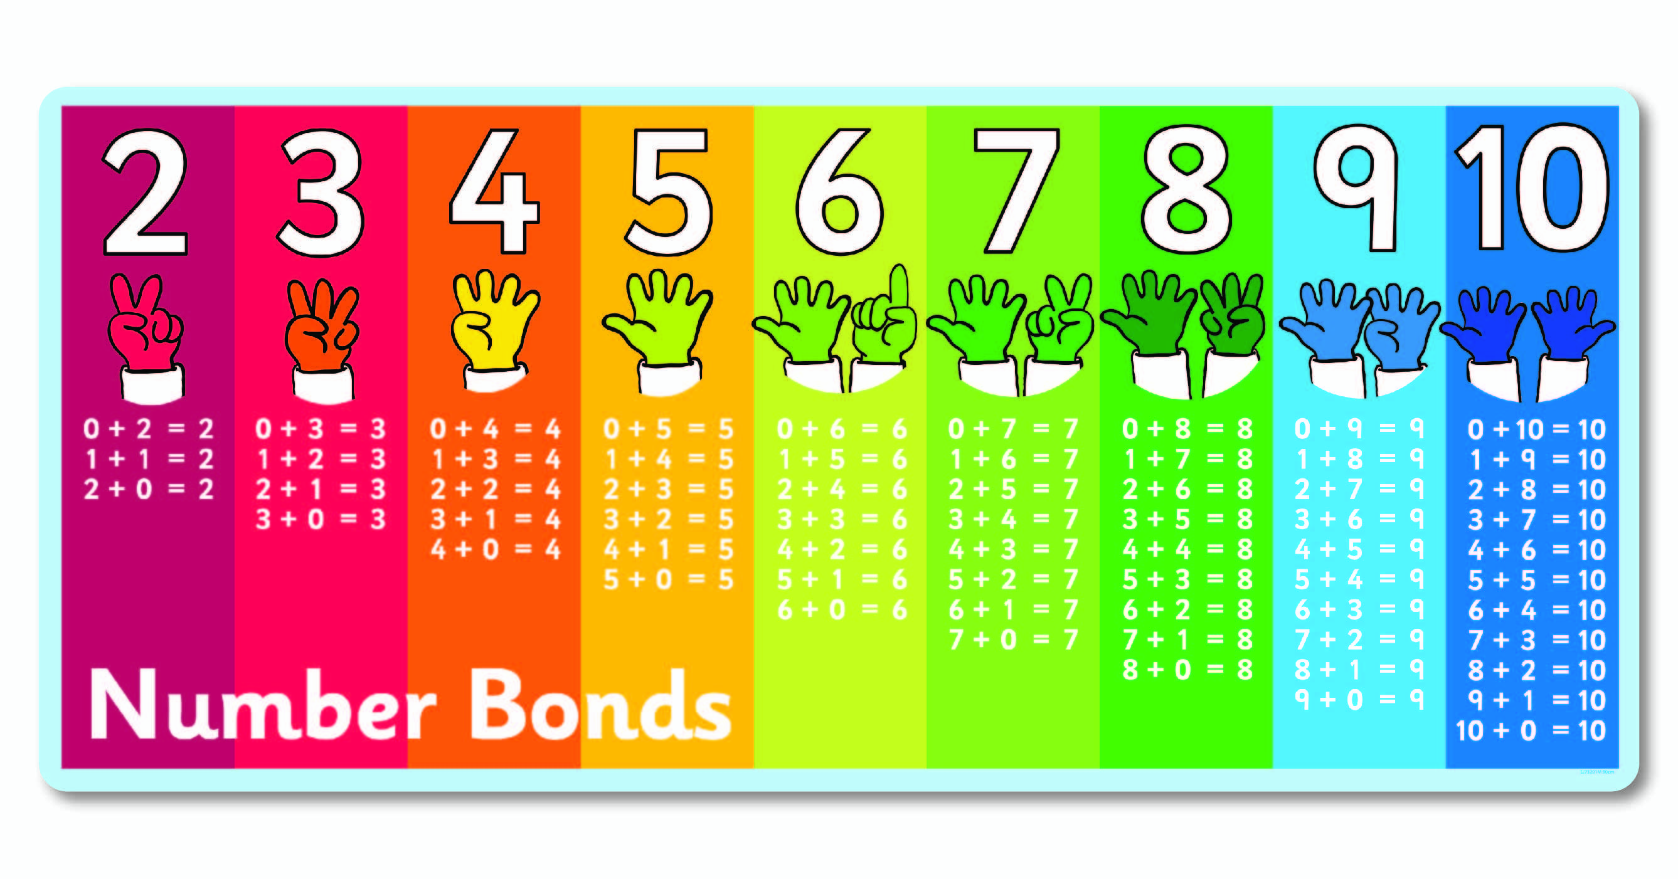](https://www.snappyjack.co.uk/number-bonds-two-to-ten)the basis of a sound understanding of number which can be built on when learning new concepts. Playing mental maths games and answering mental arithmetic questions and repeating number bonds helps children to learn and become familiar with them. This makes progression in number work easier as the concepts get harder.

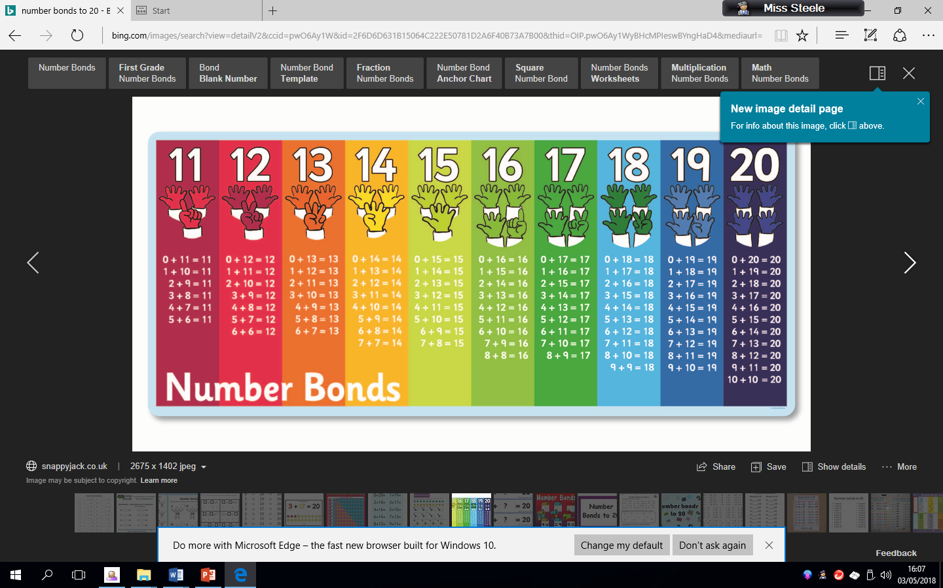

Mental maths games to support number bonds

* **Finger Speed-Sums**   
  Students meet in pairs with one hand behind their back. On the count of three, they each put forward some number of fingers. Whoever says the sum first wins. Then the pair breaks up and each person finds a new person to play with. Advanced players can use two hands instead of just one.
* **Cat and Mouse Addition** **:** All students have a number pinned to their backs. A cat is chosen and given a math problem to solve. The cat must chase the mice until she has caught a mouse with the correct answer on his or her back.
  + **Number bond snap.**
  + **Number bond bingo.**
  + **Number bond memory pairs.**

Mental Maths strategies

Addition using partitioning

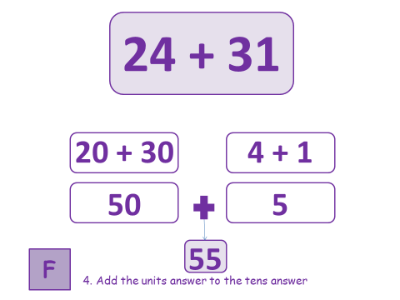

To add 2 digits (T, U) to 2 digits (T, U) mentally, you can use partitioning.

Example: 24 + 31

1. Partition the number 24 into 20 and 4 (2 tens, 4 units).
2. Partition the number 31 into 30 and 1 (3 tens, 1 unit)
3. Now add the tens together. Say 30 add 20 equals 50.
4. Add the units together. Say 4 add 1 equals 5.
5. Finally add the total tens and total units together. Say 50 add 5 equals 55.

Subtraction

Written methods – without borrowing/exchanging

Subtraction with Thousand, Hundreds, Tens and Units (Th, H, T, U)

|  |  |  |  |  |  |  |  |  |  |  |  |  |  |  |  |
| --- | --- | --- | --- | --- | --- | --- | --- | --- | --- | --- | --- | --- | --- | --- | --- |
| A) | T | U |  |  |  | H | T | U |  |  | Th | H | T | U |  |
|  | 4 | 5 |  |  |  | 5 | 6 | 1 |  |  | 1 | 2 | 5 | 4 |  |
| - | 1 | 3 |  |  | - | 2 | 4 | 0 |  | - | 1 | 1 | 3 | 2 |  |
|  | 3 | 2 |  |  |  | 3 | 2 | 1 |  |  | 0 | 1 | 2 | 2 |  |
|  |  |  |  |  |  |  |  |  |  |  |  |  |  |  |  |
|  |  |  |  |  |  |  |  |  |  |  |  |  |  |  |  |
|  |  |  |  |  |  |  |  |  |  |  |  |  |  |  |  |
|  |  |  |  |  |  |  |  |  |  |  |  |  |  |  |  |

Method

Example A- Subtraction of 2 digits (T,U)

1. Check the sign and ask, is it addition or subtraction?
2. Start with the units’ column (U). Subtract the 2 numbers. Say 5 take away 3 equals 2. Write the answer in the units’ column.
3. Move to the tens’ column (T). Subtract the 2 numbers. Say 4 take away 1 equals 3. Write the answer in the tens column.

Example B – Subtraction of 3 digits (H, T,U)

1. Check the sign and ask, is it addition or subtraction?
2. Start with the units’ column (U). Subtract the 2 numbers. Say 1 take away 0 equals 1. Write the answer in the units’ column.
3. Move to the tens’ column (T). Subtract the 2 numbers. Say 6 take away 4 equals 2. Write the answer in the tens column.
4. Move to the hundreds column (H). Subtract the 2 numbers. Say 5 take away 2 equals 3. Write the answer in the hundreds column.

Example C – Subtraction of 4 digits (Th, H, T,U)

1. Check the sign and ask, is it addition or subtraction?
2. Start with the units’ column (U). Subtract the 2 numbers. Say 4 take away 2 equals 2. Write the answer in the units’ column.
3. Move to the tens’ column (T). Subtract the 2 numbers. Say 5 take away 3 equals 2. Write the answer in the tens column.
4. Move to the hundreds column (H). Subtract the 2 numbers. Say 2 take away 1 equals 1. Write the answer in the hundreds column.
5. Move to the thousands column (Th). Subtract the 2 numbers. Say 1 take away 1 equals 0. Write the answer in the thousands column.

Subtraction with exchanging/borrowing with Hundreds, Tens and Units (Th, H, T, U)

|  |  |  |  |  |  |  |  |  |  |  |  |  |  |  |  |  |  |  |  |  |
| --- | --- | --- | --- | --- | --- | --- | --- | --- | --- | --- | --- | --- | --- | --- | --- | --- | --- | --- | --- | --- |
| A) | T | U |  |  | B) | H | T | U |  | |  | C) | H | | T | | U | | |  |
|  | 56 | 12 |  |  |  | 45 | 123 | 1111 |  | |  |  | 45 | | 910 | | 10 | | |  |
| - | 3 | 9 |  |  | - | 2 | 4 | 3 |  | |  | - | 1 | | 3 | | 9 | | |  |
|  | 2 | 3 |  |  |  | 2 | 8 | 8 |  | |  |  | 3 | | 6 | | 1 | | |  |
|  |  |  |  |  |  |  |  |  |  | |  |  |  | |  | |  | | |  |
|  |  |  |  |  |  |  |  |  |  | |  |  |  | |  | |  | | |  |

Method

Example A- subtraction of 2digits (T, U) with exchanging/borrowing

1. Check the sign and ask, is it addition or subtraction?
2. Start with the units’ column (U). Say “Is 2 smaller than 9, yes, so you have to borrow ten from the next column”. Go to the tens column put a line through 6 and make it a 5. Then take the 1 ten over to the 2 units so it becomes 12. Now complete the calculation 12 takeaway 9 equals 3. Write this in the units column.
3. Move left to the tens column (T). Say is 5 smaller than 3, no, so complete the calculation 5 tens takeaway 3 tens equals 2 tens. Write this number in the tens column (T).

Example B – subtraction of 3 digits (H, T,U) with exchanging/borrowing

1. Check the sign and ask, is it addition or subtraction?
2. Start with the units’ column (U). Say “Is 1 smaller than 3, yes, so you have to borrow ten from the next column”. Go to the tens column put a line through 3 and make it a 2. Then take the 1 ten over to the 1 unit so it becomes 11. Now complete the calculation 11 takeaway 3 equals 8. Write this in the units column (U).
3. Move left to the tens column (T). Say “Is 2 smaller then 4, yes, so you have to borrow a ten from the next column”. Go to the hundreds column put a line through 5 and make it a 4. Then take the 1 hundred over to the 2 tens so it becomes 12 tens. Now complete the calculation 12 tens takeaway 4 tens equals 8 tens. Write this in the tens column.
4. Move left to the Hundreds column (H). Say is 4 smaller than 2, no, so complete the calculation 4 hundreds takeaway 2 hundreds equals 2 hundreds. Write the 2 in the hundreds column (H).

Example C – subtraction of 3 digits (H, T,U) with exchanging/borrowing

1. Check the sign and ask, is it addition or subtraction?
2. Start with the units’ column (U). Say “Is 0 smaller than 9, yes, so you have to borrow ten from the next column”. Go to the tens column. Because there is 0 tens in this column we have to go to the next column to the left which is the hundreds column (H). In the hundreds column, put a line through the 5 and write 4.
3. Take the 1 hundred to the 0 tens and make it 10 tens. We still need to exchange 1 ten into the units column so we now score out the 10 tens and write 9 tens and take the 1 ten and add it to the 0 units to make 10 units.
4. Now we can complete the units calculation. Say 10 takeaway 9 equals 1. Write 1 in the units column (U).
5. Move left to the tens column. Say 9 tens takeaway 3 tens equals 6 tens. Write 6 in the tens column (T).
6. Move left to the hundreds column (H). Say 4 hundreds takeaway 1 hundred equals 3 hundreds. Write the 3 in the hundreds column (H).



Mental Maths strategies-

Number bonds to 20 quick recall

Basic number bonds are critical foundations for maths and provide

the basis of a sound understanding of number which can be built on when learning new concepts. Playing mental maths games and answering mental arithmetic questions and repeating number bonds helps children to learn and become familiar with them. This makes progression in number work easier as the concepts get harder.

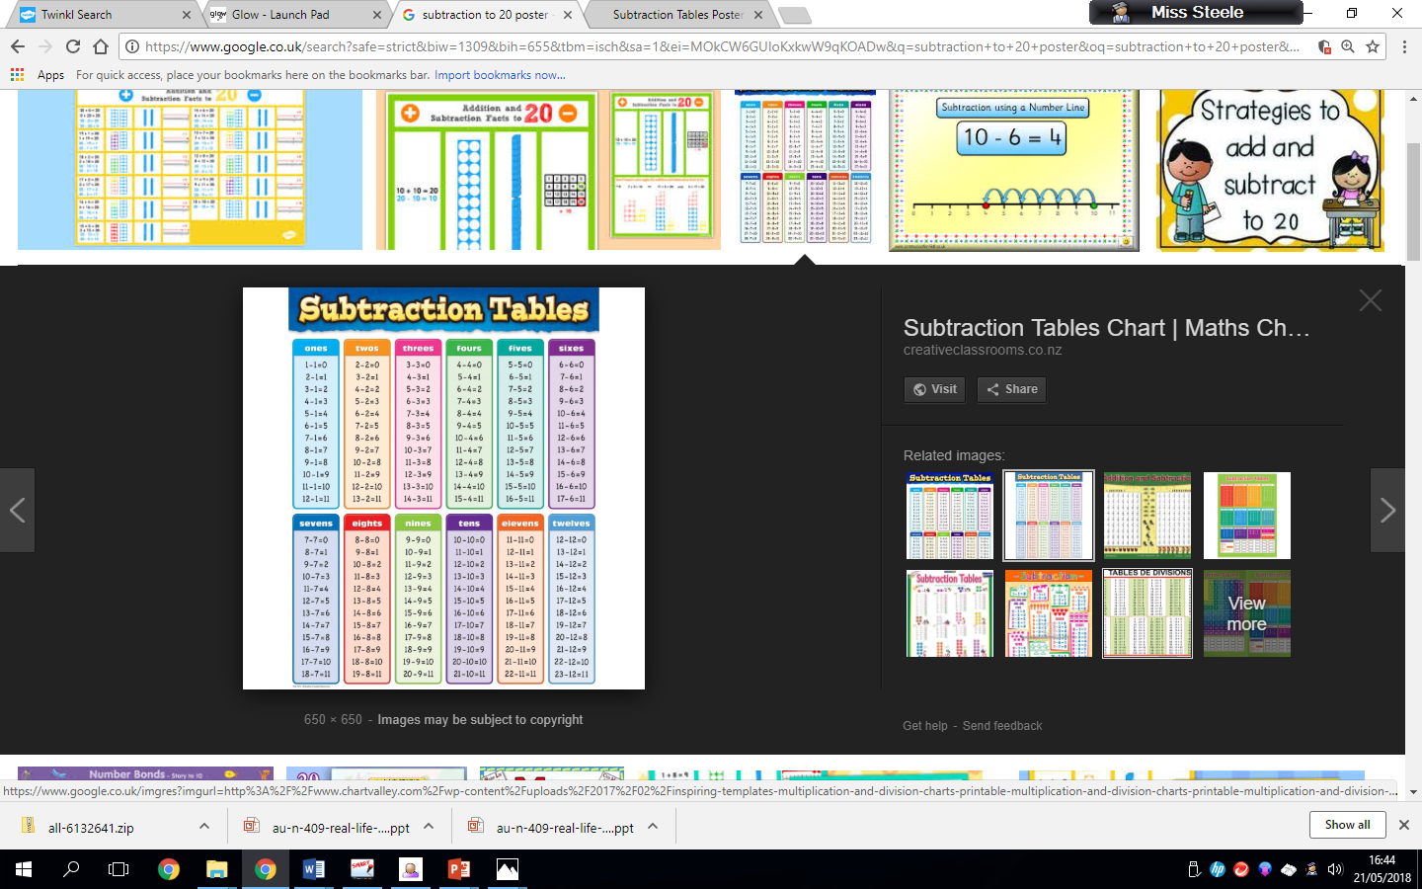

Mental maths strategies

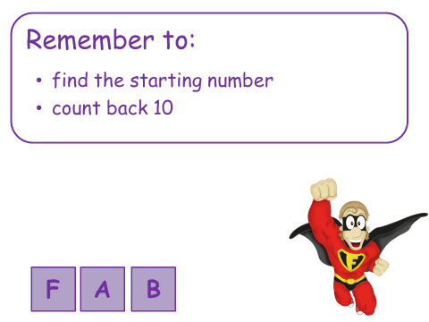Counting back

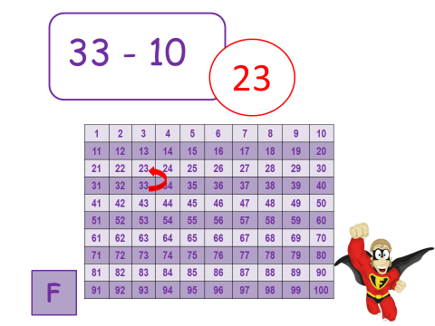Example:

Find the starting number which is 33.

Count back 10 to 23.

Mental maths strategies – Find the Gap

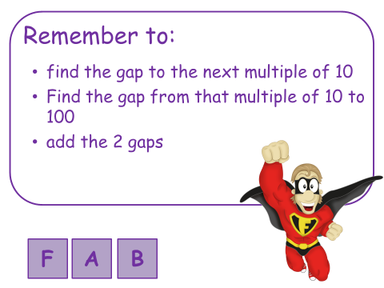

Example: 100-75

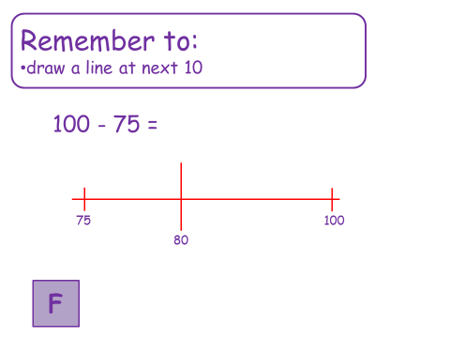

1. Show the numbers on a number line.
2. Find the gap to the next multiple of 10. The next multiple of 10 for the number 75 is 80. The gap is 5 since 80 takeaway 75 equals 5.
3. Find the gap between the multiple of 10 and 100. 100 takeaway 80 equals 20.
4. Add the 2 gaps together. 20 add 5 equals 25.

Multiplication

Written methods

Multiplying with Hundreds, Tens and Units (H, T, U)

|  |  |  |  |  |  |  |  |  |  |  |  |  |  |  |
| --- | --- | --- | --- | --- | --- | --- | --- | --- | --- | --- | --- | --- | --- | --- |
|  | A) | T | U |  | B) | H | T | U |  | C) | H | T | U |  |
|  |  | 3 | 1 |  |  | 1 | 2 | 2 |  |  | 1 | 3 | 2 |  |
|  | X |  | 3 |  | X |  |  | 4 |  | X |  |  | 2 |  |
|  |  | 9 | 3 |  |  | 4 | 8 | 8 |  |  | 2 | 69 | 4 |  |
|  |  |  |  |  |  |  |  |  |  |  |  |  |  |  |
|  |  |  |  |  |  |  |  |  |  |  |  |  |  |  |
|  |  |  |  |  |  |  |  |  |  |  |  |  |  |  |
|  |  |  |  |  |  |  |  |  |  |  |  |  |  |  |

Method

Example A- multiplying 2 digits (T, U) by 3

1. Start from the Unit column (U). Say 1 times 3 equals 3. Write the 3 in the Units column (U).
2. Move left to the Tens column (T). Say 3 tens times 3 equals 9 tens. Write the 9 in the Tens column (T).

Example B – multiplying 3 digits (H, T, U) by 4

1. Start from the Unit column (U). Say 2 times 4 equals 8. Write the 8 in the Units column (U).
2. Move left to the Tens column (T). Say 2 tens times 4 equals 8 tens. Write the 8 in the Tens column (T)
3. Move left to the Hundreds column (H). Say 1 hundred times 4 equals 4 hundreds. Write the 4 in the hundreds column (H).

Example C – multiplying 3 digits (H, T, U) by 2

1. Start from the Unit column (U). Say 2 times 2 equals 4. Write the 4 in the Units column (U).
2. Move left to the Tens column (T). Say 3 tens times 2 equals 6 tens. Write the 6 in the Tens column (T).
3. Move left to the Hundreds column (H). Say 1 hundred times 2 equals 2 hundreds. Write the 2 in the hundreds column (H).

Multiplying with Hundreds, Tens and Units (H,T,U) with carrying

|  |  |  |  |  |  |  |  |  |  |  |  |  |  |  |
| --- | --- | --- | --- | --- | --- | --- | --- | --- | --- | --- | --- | --- | --- | --- |
|  | A)) | T | U |  | B) | H | T | U |  |  | H | T | U |  |
|  |  | 5 | 1 |  |  |  | 6 | 5 |  |  | 1 | 6 | 4 |  |
|  | X |  | 4 |  | X |  |  | 3 |  | X |  |  | 5 |  |
|  | 2 | 0 | 4 |  |  | 1 | 9 | 5 |  |  | 8 | 2 | 0 |  |
|  |  |  |  |  |  |  | 1 |  |  |  | 3 | 2 |  |  |
|  |  |  |  |  |  |  |  |  |  |  |  |  |  |  |
|  |  |  |  |  |  |  |  |  |  |  |  |  |  |  |
|  |  |  |  |  |  |  |  |  |  |  |  |  |  |  |

Method

Example A – multiplying 2 digits (T, U) by 4 with carrying

1. Start from the Unit column (U). Say 1 times 4 equals 4. Write the 4 in the Units column (U).
2. Move left to the Tens column (T). Say 5 tens times 4 equals 20 tens. Write the 0 in the Tens column (T) and create a new column to the left for hundreds (H). Write the 2 in the hundreds column (H).

Example B – multiplying 2 digits (T, U) by 3 with carrying

1. Start from the Unit column (U). Say 5 times 3 equals 15. Write the 3 in the Units column (U) and write the 1 ten under the tens column.
2. Move left to the Tens column (T). Say 6 tens times 3 equals 18 tens. You then add the 1 ten that was carried over to make 19 tens. Write the 9 in the tens column (T) and create a new column to the left for hundreds (H). Write the 1 in the hundred column (H).

Example C – multiplying 3 digits (T, U) by 5 with carrying

1. Start from the Unit column (U). Say 4 times 5 equals 20. Write the 0 in the Units column (U) and write the 2 under the tens column.
2. Move left to the Tens column (T). Say 6 tens times 5 equals 30 tens. You then add the 2 tens that you carried over to make 32 tens. Write the 2 in the tens column (T) and write the 3 under the hundreds column (H).
3. Move left to the Hundreds column (H). Say 1 hundred times 5 equals 5 hundreds then add the 3 that was carried over to make 8 hundreds. Write the 8 in the hundred column (H).

REMEMBER! – always multiply each column first before adding any number you have carried over!

Mental Maths strategies-

Times table facts

Basic times table facts are critical foundations for maths and provide the basis of a sound understanding of number which can be built on when learning new concepts. Playing mental maths games and answering mental arithmetic questions and repeating and reciting times table facts helps children to learn and become familiar with them. This makes progression in number work easier as the concepts get harder.

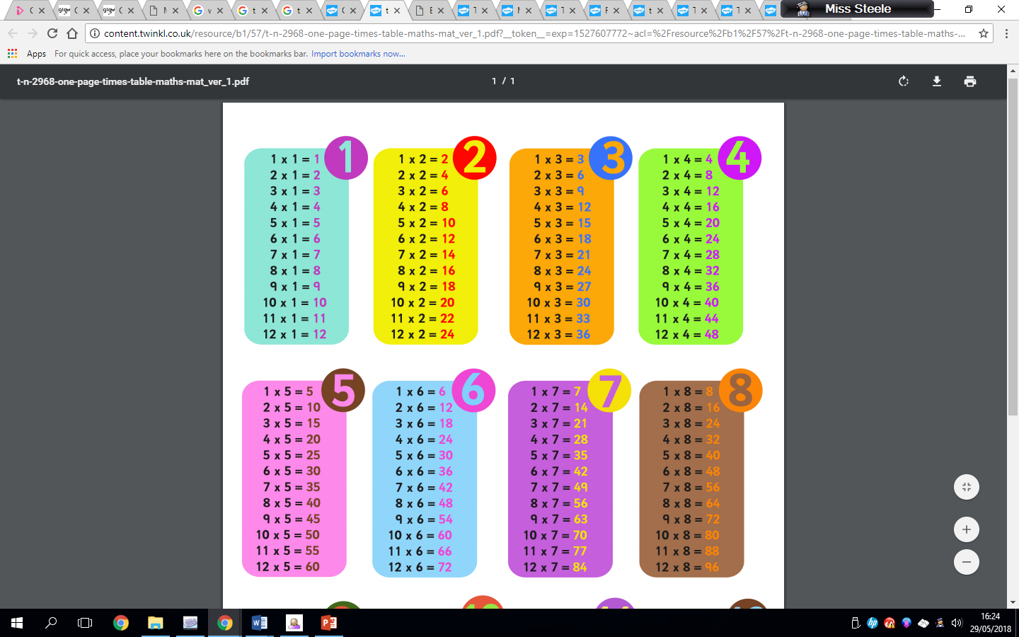

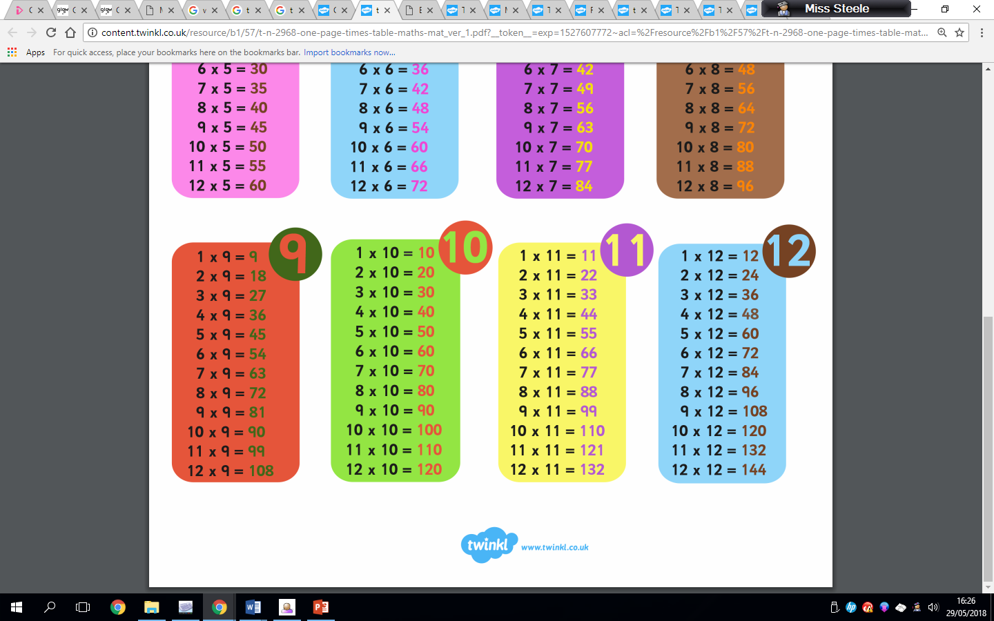

Mental maths games to support times tables

* **Finger Speed-Sums**   
  Students meet in pairs with one hand behind their back. On the count of three, they each put forward some number of fingers. Whoever says the sum first wins. Then the pair breaks up and each person finds a new person to play with. Advanced players can use two hands instead of just one.
  + **Times table snap.**
  + **Times table bingo.**
  + **Times table memory pairs.**
  + **Around the world**

Everyone sits in a circle. Select a quiz master and someone to start. The starting person stands behind another and the quiz master asks a random times table question. The one who answers correctly the fastest either moves on or swaps places with the person standing. Repeat until everyone has had a go.

* + **Ninja chop**

You need three people to play this game. One person to be the quiz master and two to play. The quiz master asks a random times table question and the players have to shout the correct answer whilst forming the numbers in the air with their hands.

Using 1d x 1d facts to create fact families

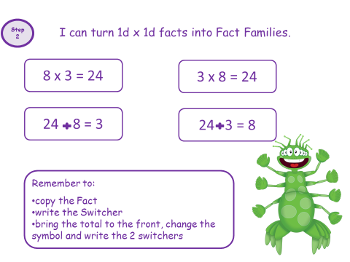

Children will create fact families to help them understand that multiplication and division are the inverse of each other.

Example using 8, 3 and 24.

8 x 3 = 24 24 divided by 8 = 3

3 x 8 = 24 24 divided by 3 = 8

Triangles showing the 3 digits are also used to consolidate this understanding.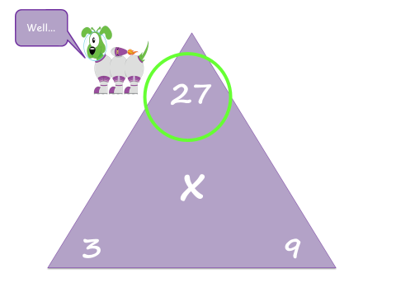

**8**

**24**

Division

Division by sharing equally

When introducing the concept of division, it is useful to view division as sharing equally between a number of groups. It can be helpful to use concrete materials to help children physically share out the objects.

Example: 16 divided by 4.

Using oranges, the children can share these equally into 4 groups to understand that each group would receive 4 oranges. They will then write the number sentence, 16 divided by 4 = 4.

[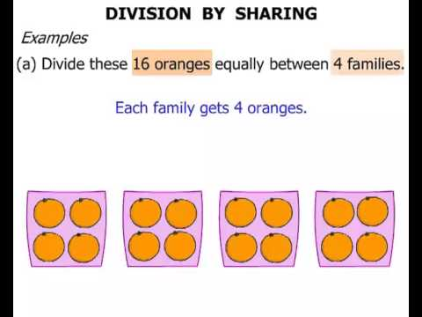](https://www.google.co.uk/url?sa=i&rct=j&q=&esrc=s&source=images&cd=&cad=rja&uact=8&ved=&url=https://www.youtube.com/watch?v%3D9viaFlKIYyU&psig=AOvVaw2a01-1hrAxf2bxDe-3CniY&ust=1536914107789667)

Written methods

Dividing with Tens and Units (T, U) with no remainders

|  |  |  |  |  |  |  |  |  |  |  |  |  |
| --- | --- | --- | --- | --- | --- | --- | --- | --- | --- | --- | --- | --- |
|  |  | T | U |  |  |  | T | U |  |  |  |  |
|  | A) | 1 | 2 |  |  | B)) | 2 | 3 |  |  |  |  |
|  | 4 | 4 | 8 |  |  | 3 | 6 | 9 |  |  |  |  |
|  |  |  |  |  |  |  |  |  |  |  |  |  |
|  |  |  |  |  |  |  |  |  |  |  |  |  |
|  |  |  |  |  |  |  |  |  |  |  |  |  |
|  |  |  |  |  |  |  |  |  |  |  |  |  |
|  |  |  |  |  |  |  |  |  |  |  |  |  |

Example A – Dividing 2 digits by 4 (T, U)

1. Start with the furthest column to the left inside the ‘bus stop’, in this example the Tens column (T). Say 4 divided by 4, how many 4’s are there in 4?. There is 1 4 in 4. 1 goes on top of the line above the Tens column (T).
2. Move right to the units column (U). Say 8 divided by 4. how many 4’s are in 8?. There are 2. 2 goes on top of the line above the units column (U).

Example B – Dividing 2 digits by 3 (T, U)

1. Start with the furthest column to the left inside the ‘bus stop’, in this example the Tens column (T). Say 6 divided by 3, how many 3’s are there in 6?. There is 2 3’s in 6. 2 goes on top of the line above the Tens column (T).
2. Move right to the units column (U). Say 9 divided by 3. how many 3’s are in 9?. There are 3 3’s in 9. 3 goes on top of the line above the units column (U).

Tip! It can be helpful for your child to write out the times table that they are dividing by in full e.g. 3 x 1 = 3 etc.

This will help them be able to see how many 3’s are in a number using their tables knowledge.

Written methods

Dividing with Tens and Units (T, U) with remainders

|  |  |  |  |  |  |  |  |  |  |  |  |  |
| --- | --- | --- | --- | --- | --- | --- | --- | --- | --- | --- | --- | --- |
|  |  | T | U |  |  |  | T | U |  |  |  |  |
|  | A) | 1 | 4r | r1 |  | B)) | 2 | 6 | r1 |  |  |  |
|  | 4 | 5 | 17 |  |  | 3 | 7 | 19 |  |  |  |  |
|  |  |  |  |  |  |  |  |  |  |  |  |  |
|  |  |  |  |  |  |  |  |  |  |  |  |  |
|  |  |  |  |  |  |  |  |  |  |  |  |  |
|  |  |  |  |  |  |  |  |  |  |  |  |  |
|  |  |  |  |  |  |  |  |  |  |  |  |  |

Example A – Dividing 2 digits by 4 (T, U) with a remainder

1. Start with the furthest column to the left inside the ‘bus stop’, in this example the Tens column (T). Say 5 divided by 4, how many 4’s are there in 5?. There is 1 4 in 5 because 4x1 = 4. 1 goes on top of the line above the Tens column (T). You have only used 4 out of the 5 tens therefore there is 1 left. This 1 ten is carried over to the units column to add to the 7 making it now 17 units.
2. Move right to the units column (U). Say 17 divided by 4. how many 4’s are in 17?. There are 4 4’s in 17 because 4 x 4 = 16. 4 goes on top of the line above the units column (U). You have only used 16 out of the 17 units therefore there is 1 left. Because there is not another number to the right, this number is written as a remainder beside the answer as r 1.

Example B – Dividing 2 digits by 3 (T, U) with a remainder

1. Start with the furthest column to the left inside the ‘bus stop’, in this example the Tens column (T). Say 7 divided by 3, how many 3’s are there in 7?. There is 2 3’s in 7 because 2x3=6. 2 goes on top of the line above the Tens column (T). You have only used 6 out of the 7 tens therefore there is 1 left. This 1 ten is carried over to the units column to add to the 9 making it now 19 units.
2. Move right to the units column (U). Say 19 divided by 3. how many 3’s are in 19?. There are 6 3’s in 19 because 3x6 = 18. 3 goes on top of the line above the units column (U). You have only used 18 out of the 19 units therefore there is 1 left. Because there is not another number to the right, this number is written as a remainder beside the answer as r 1.

Mental Maths strategies-

Division facts

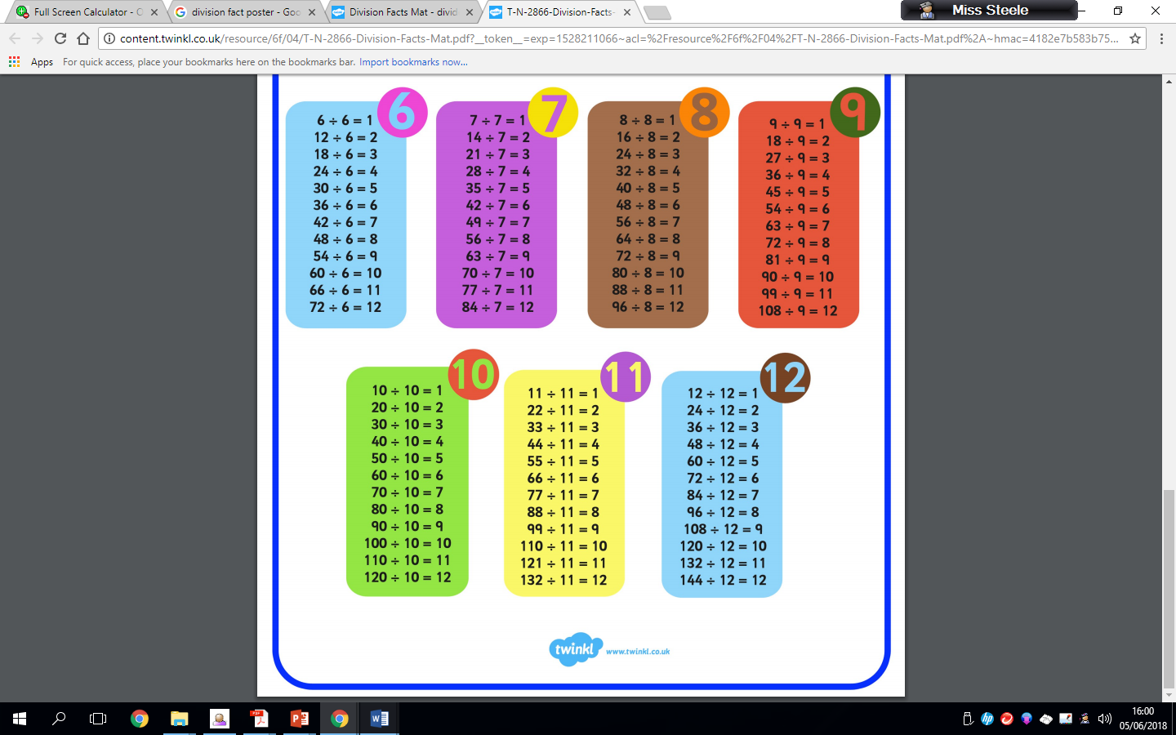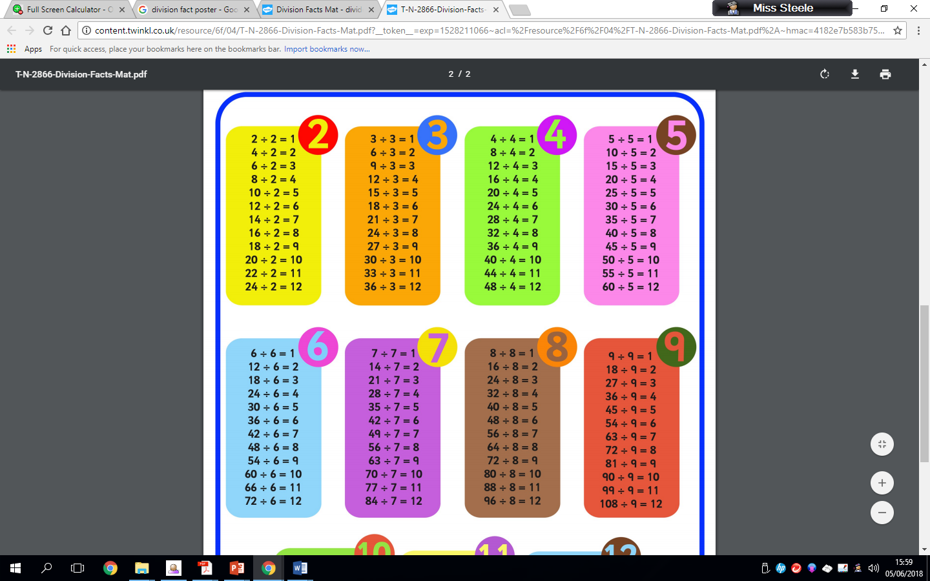Basic times table/division facts are critical foundations for maths and provide the basis of a sound understanding of number which can be built on when learning new concepts. Playing mental maths games and answering mental arithmetic questions and repeating and reciting times table/division facts helps children to learn and become familiar with them. This makes progression in number work easier as the concepts get harder

Mental maths games to support times tables

* **Finger Speed-Sums**   
  Students meet in pairs with one hand behind their back. On the count of three, they each put forward some number of fingers. Whoever says the sum first wins. Then the pair breaks up and each person finds a new person to play with. Advanced players can use two hands instead of just one.
  + **Division snap.**
  + **Division bingo.**
  + **Division memory pairs.**
  + **Around the world**

Everyone sits in a circle. Select a quiz master and someone to start. The starting person stands behind another and the quiz master asks a random division question. The one who answers correctly the fastest either moves on or swaps places with the person standing. Repeat until everyone has had a go.

* + **Ninja chop**

You need three people to play this game. One person to be the quiz master and two to play. The quiz master asks a random division question and the players have to shout the correct answer whilst forming the numbers in the air with their hands.

Fact Families

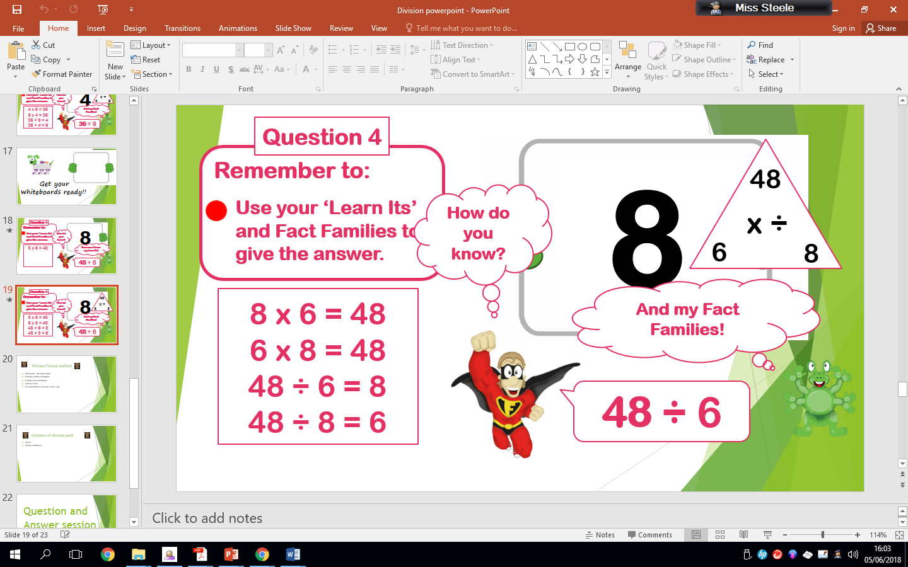

To solve 48 divided by 6 children should use their ‘Learn its’ and Fact Families to give the answer. The children should be aware that there are 4 facts for each division statement, 2 of which are multiplication and 2 of which are division. E.g. the fact families of 48 divided by 6 are 8 x 6 = 48, 6 x 8 = 48, 48 divided 6 = 8 and 48 divided 8 = 6.