Cairns Nursery Class Newsletter November 2019

Dear Parents/Carers,
This term has been super busy! We have celebrated Achievement Day and Halloween, we have harvested our potatoes and been busy making soup, we have a new focus and we have started practising for our nursery nativity. We have lots of lovely things planned in the run up to Christmas, so keep your eye on our noticeboard for reminders.
Dates for the Diary
- Thursday 14th November – Book sale
- Friday 15th November – Teddy Bears Picnic
- Monday and Tuesday 18th and 19th November – In Service Days
- Thursday 28th November – Christmas Fayre 4-6pm
- Wednesday 4th December – Afternoon Nativity
- Friday 6th December – Morning Nativity
- Thursday 12th December – Nursery closed for election
- Friday 13th December – Christmas Parties
- Friday 20th December - closed at 2.30pm for Christmas Holidays
- Monday 6th January – Nursery returns after Christmas

Nursery Noticeboard and events Please keep an eye on the noticeboard during the session to make sure you keep up to date with all of the activities and events we have planned for our nursery children this term.
Upcoming events
Thursday 14th November –
Book Sale
We have had books kindly donated for sale. Books will not be priced however we do ask that you give a donation of your choice.
Friday 15th November –
Teddy Bear Picnic.
Children can bring their favourite teddy and wear their pyjamas to nursery. Please make sure teddies are labelled to avoid mix-ups.
Thursday 13th December
Christmas Party
All children should attend the morning session for their party. There will be no afternoon session on the 13th December.
Nursery Nativity
This year we will be performing the ‘Nursery Rhyme’ Nativity.
- Wednesday 4th December – 2pm performance for our PM class.
- Friday 6th December – 10am performance for our AM class
Tickets will be available to buy in nursery from 20th November, priced £2 adults and £1 concessions.

Update
Keep an eye on our wall displays to find out about your child’s progress, our nursery planning and new concepts being introduced in our nursery class…
Watch us Grow – watch our flower board bloom as we add the children’s achievements petal by petal.
Uniforms – we have sourced new nursery uniforms that can be ordered online. Please see Mrs Burns for details.
Weather appropriate clothing – as the weather gets colder the children will need warmer clothes. Please make sure children have a warm jacket for outdoor play. Could you also make sure that all items of clothing are clearly labelled with your child’s name? Thank you.
Our Learning
Our focus for learning is Fairy Tales. The children have already started exploring the different fairy tale stories focussing on storytelling and characters and events in the story. They have been using their role play skills in the three bears cave and have been enjoying reading in the enchanted forest. We are looking forward to seeing where their interests will take us on our learning journey. If there is anything you would like to share with the children, or anything you think should be included in their learning please share with a member of staff. Keep an eye on our learning board for weekly updates on what the children are learning in nursery.

Nursery session times
- Morning session 8.45am – 11.55am
- Afternoon Session 1.00pm- 4.10pm

Recently there have been a number of occasions where parents have been late to pick up their children. This effects staff lunches and when they can finish at the end of the day. We understand that things can happen unexpectedly and there may be times you are running late, but if you could phone to let the nursery know this would be appreciated.
Nursery Absence
If your child is off nursery please call the school on 0141 641 2218 to report your child’s absence. Absences from nursery are recorded and followed up. When calling if you choose Option 3 you can speak directly to a member of the Nursery staff or will be able to leave a message. We kindly ask you to phone to make staff aware of any changes to who is picking up your child from nursery. Our Nursery staff have their lunch break between 12 noon and 1.00pm, and will therefore be unavailable to answer phone calls at this time.

Our new friend Buddy is excited to go home with the children. Buddy will go home on a Friday with one child and should be returned on a Monday
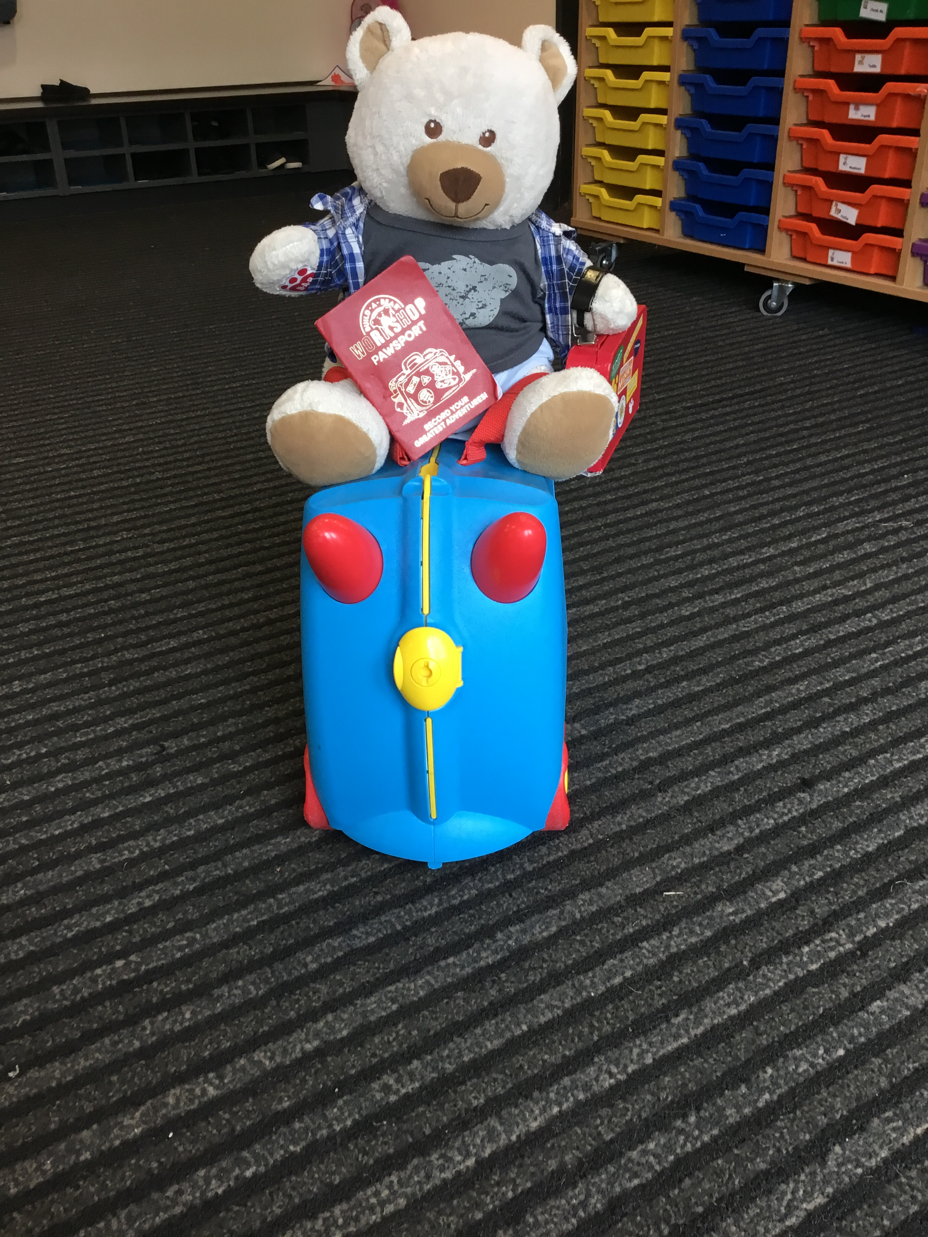

Emergency Contact Numbers
Please remember to update us if your contact details change, as we need to be able to contact parents/carers in case of emergency. If you have a new mobile number, please ensure that this is passed on to staff.

