

Cairns Primary School

Numeracy and Maths

Second Level Addition, Subtraction, Multiplication and Division Help sheet

Dear Parent / Carer,

During a recent consultation with parents about how we best support you, and your child with maths, it was suggested that help sheets highlighting what is taught in maths and how we do it would be helpful for parents in assisting their child with maths and numeracy.

The following Learning Help booklet is aimed at providing parents and carers with information to support their children when completing Numeracy calculations at home. We hope it will provide you with detailed steps on how to complete each calculation using the methodology that will be taught in school for Addition, Subtraction, Multiplication and Division. This will ensure that pupils receive consistency helping your child to consolidate their understanding in these areas.

Please give your comments and feedback on this booklet so we can adjust, improve and supplement it for parents.

Raising Attainment in Maths Working Party

|  |  |
| --- | --- |
| Maths Vocabulary  It is important your child knows there are lots of words and ways used to describe key maths calculations. | |
| Addition | Subtraction |
| +  add  plus  make  Find the sum of…  How many altogether?  Find the total  How many more? | -  subtract  Take away  Find the difference between  minus  How many less? |
| Multiply | Divide |
| X  multiplication  Times  Groups of  Multiples of  Repeated addition  Multiplied by  Lots of  Product | ÷  division  Share  Divided by  Divided into  Share equally  Equal groups of |

Layout

When setting out sums in a jotter it is important to only allocate one number per box and the sign (+ - x) should not sit under the numbers.

|  |  |  |  |  |  |  |  |  |  |  |  |  |  |  |  |
| --- | --- | --- | --- | --- | --- | --- | --- | --- | --- | --- | --- | --- | --- | --- | --- |
|  |  |  |  |  |  |  |  |  |  |  |  |  |  |  |  |
|  |  | 4 | 2 |  |  |  | 5 | 7 |  |  |  | 4 | 2 |  |  |
|  | + |  | 6 |  |  | - | 2 | 3 |  |  | x |  | 6 |  |  |
|  |  | 4 | 8 |  |  |  | 3 | 4 |  |  | 2 | 5 | 2 |  |  |
|  |  |  |  |  |  |  |  |  |  |  |  | 1 |  |  |  |

Before you begin always check the sign

Addition

Written methods - carrying.

Adding with Thousand, Hundreds, Tens and Units (Th, H, T, U)

|  |  |  |  |  |  |  |  |  |  |  |  |  |
| --- | --- | --- | --- | --- | --- | --- | --- | --- | --- | --- | --- | --- |
|  |  | Th | H | T | U |  |  | Th | H | T | U |  |
|  |  | 1 | 8 | 4 | 5 |  |  | 3 | 6 | 7 | 3 |  |
|  | + | 3 | 1 | 5 | 2 |  | + | 1 | 3 | 4 | 8 |  |
|  |  | 4 | 9 | 9 | 7 |  |  | 5 | 0 | 2 | 1 |  |
|  |  |  |  |  |  |  |  | 1 | 1 | 1 |  |  |
|  |  |  |  |  |  |  |  |  |  |  |  |  |
|  |  |  |  |  |  |  |  |  |  |  |  |  |
|  |  |  |  |  |  |  |  |  |  |  |  |  |

Method

Example A-No carrying

1. Check the sign and ask, is it addition or subtraction?
2. Start with the units’ column (U). Add the 2 numbers together. Write the answer under the units’ column.
3. Move to the tens’ column (T). Add the 2 numbers together. Write the answer under the tens column.
4. Move to the hundreds column (H). Add the 2 numbers together. Write the answer under the hundreds column.
5. Move to the thousands column (Th). Add the 2 numbers together. Write the answer under the Thousands column.

Example B – Carrying

1. Check the sign and ask, is it addition or subtraction?
2. Start with the units’ column (U). Say “3 add 8 equals 11”. Place the 1 in the units’ column and place the 1 under the tens column (T).
3. Move left to the tens’ column (T). Add the tens’ column, say “7 tens add 4 tens plus the 1 ten you carried over equals 12 tens”. Place the 2 in the tens column and the 1 under the hundreds column (H).
4. Move left to the hundreds column (H). Add the hundreds column, say ‘6 hundreds add 3 hundreds plus the 1 hundred I carried over equals 10 hundreds”. Place the 0 in the hundreds column and the 1 under the thousands (Th) column.
5. Move left to the thousands column (Th). Add the thousands column, say ‘3 thousands add the 1 thousands plus the 1 thousands I carried over equals 5 thousands”. Write the answer in the thousands column.

Adding with Tens of Thousands, Thousands, Hundreds, Tens and Units (TTh,Th H,T,U)

|  |  |  |  |  |  |  |  |  |  |  |  |  |  |  |
| --- | --- | --- | --- | --- | --- | --- | --- | --- | --- | --- | --- | --- | --- | --- |
|  |  | TTh | Th | H | T | U |  |  | TTh | Th | H | T | U |  |
|  |  | 3 | 1 | 8 | 4 | 5 |  |  | 2 | 4 | 6 | 7 | 3 |  |
|  | + | 2 | 3 | 1 | 5 | 2 |  | + | 4 | 5 | 3 | 4 | 8 |  |
|  |  | 5 | 4 | 9 | 9 | 7 |  |  | 7 | 0 | 0 | 2 | 1 |  |
|  |  |  |  |  |  |  |  |  | 1 | 1 | 1 | 1 |  |  |
|  |  |  |  |  |  |  |  |  |  |  |  |  |  |  |
|  |  |  |  |  |  |  |  |  |  |  |  |  |  |  |
|  |  |  |  |  |  |  |  |  |  |  |  |  |  |  |

Method

Example A-No carrying

1. Check the sign and ask, is it addition or subtraction?
2. Start with the units column **(U**). Add the 2 numbers together. Write the answer under the units (U) column.
3. Move to the tens column (**T**). Add the 2 numbers together. Write the answer under the tens column.
4. Move to the hundreds column (**H).** Add the 2 numbers together. Write the answer under the hundreds (H) column.
5. Move to the thousands column (**Th**). Add the 2 numbers together. Write the answer under the thousands (Th) column.
6. Add the Tens of Thousands Column (**TTh).** Add the 2 numbers together. Write the answer under the tens of thousands (TTh) column.

Example B – Carrying

1. Check the sign and ask, is it addition or subtraction?
2. Start with the units’ column (**U**). Say “3 add 8 equals 11”. Place the 1 in the units column and place the 1 under the tens (T) column.
3. Move left to the tens column (**T**). Add the tens column, say “7 tens add 4 tens plus the 1 ten you carried over equals 12 tens”. Place the 2 in the tens column and the 1 under the hundreds (H) column.
4. Move left to the hundreds column. (**H**) Add the hundreds column, say ‘6 hundreds add 3 hundreds plus the 1 hundred I carried over equals 10 hundreds”. Place the 0 in the hundreds column and the 1 under the thousands (Th) column.
5. Move left to the thousands column (**Th**). Add the thousands column, say ‘4 thousands add the 5 thousands plus the 1 thousands I carried over equals 10 thousands”. Place the 0 in the thousands column and the 1 under the Tens of Thousands column (TTh).
6. Move left to the tens of thousands column (**TTh**). Add the tens of thousands column, say ‘2 of tens of thousands add the 4 tens of thousands plus the 1 thousands I carried over equals 7 tens of thousands”. Write the answer under the tens of thousands (**TTh**) column.

Adding with Hundreds of Thousands, Tens of Thousands, Thousands, Hundreds, Tens and Units (HTh,TTh,Th H,T,U)

|  |  |  |  |  |  |  |  |  |  |  |  |  |  |  |  |
| --- | --- | --- | --- | --- | --- | --- | --- | --- | --- | --- | --- | --- | --- | --- | --- |
|  | HTh | TTh | Th | H | T | U |  |  | HTh | TTh | Th | H | T | U |  |
|  | 5 | 7 | 8 | 1 | 1 | 0 |  |  | 3 | 2 | 4 | 6 | 7 | 3 |  |
|  | 4 | 2 | 1 | 7 | 8 | 9 |  | + | 2 | 4 | 5 | 3 | 4 | 8 |  |
|  | 9 | 9 | 9 | 8 | 9 | 9 |  |  | 5 | 7 | 0 | 0 | 2 | 1 |  |
|  |  |  |  |  |  |  |  |  |  | 1 | 1 | 1 | 1 |  |  |
|  |  |  |  |  |  |  |  |  |  |  |  |  |  |  |  |
|  |  |  |  |  |  |  |  |  |  |  |  |  |  |  |  |
|  |  |  |  |  |  |  |  |  |  |  |  |  |  |  |  |

Method

Example A-No carrying

1. Check the sign and ask, is it addition or subtraction?
2. Start with the units column **(U**). Add the 2 numbers together. Write the answer under the units (U) column.
3. Move to the tens column (**T**). Add the 2 numbers together. Write the answer under the tens column.
4. Move to the hundreds column (**H).** Add the 2 numbers together. Write the answer under the hundreds (H) column.
5. Move to the thousands column (**Th**). Add the 2 numbers together. Write the answer under the thousands (Th) column.
6. Add the Tens of Thousands Column (**TTh).** Add the 2 numbers together. Write the answer under the tens of thousands (TTh) column.

Example B – Carrying

1. Check the sign and ask, is it addition or subtraction?
2. Start with the units’ column (**U**). Say “3 add 8 equals 11”. Place the 1 in the units column and place the 1 under the tens (T) column.
3. Move left to the tens column (**T**). Add the tens column, say “7 tens add 4 tens plus the 1 ten you carried over equals 12 tens”. Place the 1 in the tens column and the 2 under the hundreds (H) column.
4. Move left to the hundreds column. (**H**) Add the hundreds column, say ‘6 hundreds add 3 hundreds plus the 1 hundred I carried over equals 10 hundreds”. Place the 0 in the hundreds column and the 1 under the thousands (Th) column.
5. Move left to the thousands column (**Th**). Add the thousands column, say ‘ 4 thousands add the 5 thousands plus the 1 thousands I carried over equals 10 thousands”. Place the 0 in the thousands column and the 1 under the Tens of Thousands column (TTh).
6. Move left to the tens of thousands column (**TTh**). Add the tens of thousands column, say ‘2 of tens of thousands add the 4 tens of thousands plus the 1 thousands I carried over equals 7 tens of thousands”. There is no need to carry over.
7. Move left to the hundreds of thousands column (**HTh**). Add the hundreds of thousands column (HTh) column say tens of thousands column, say ‘3 of tens of thousands add the 2 tens of thousands I carried over equals 5 tens of thousands”. Write the answer in the tens of thousands (**TTh**) column.

Mental Maths strategies-

Number bonds to 20 quick recall

Basic number bonds are critical foundations for maths and provide

the basis of a sound understanding of number which can be built on when learning new concepts. Playing mental maths games and answering mental arithmetic questions and repeating number bonds helps children to learn and become familiar with them. This makes progression in number work easier as the concepts get harder.

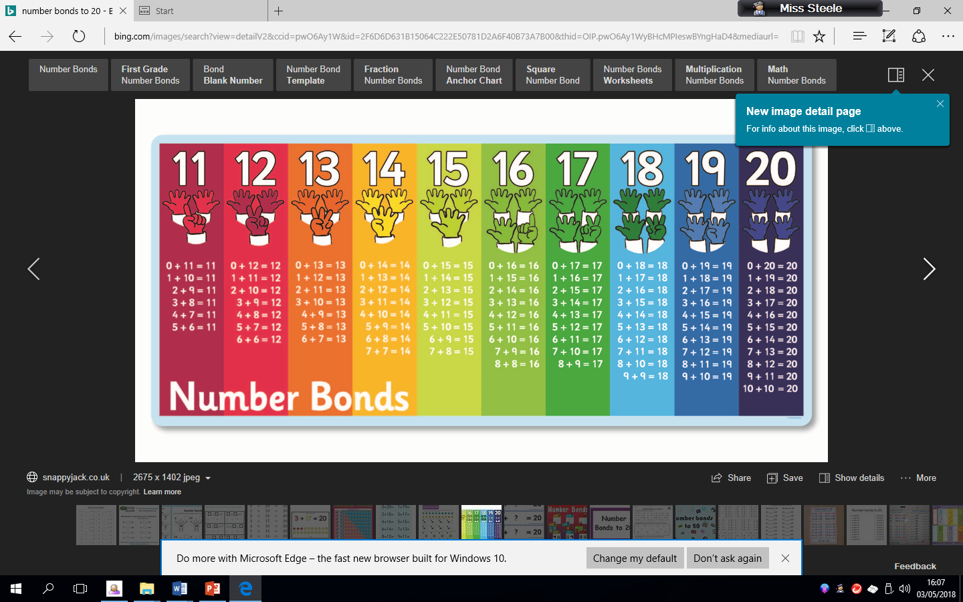



Mental maths games to support number bonds

* **Finger Speed-Sums**   
  Students meet in pairs with one hand behind their back. On the count of three, they each put forward some number of fingers. Whoever says the sum first wins. Then the pair breaks up and each person finds a new person to play with. Advanced players can use two hands instead of just one.
* **Cat and Mouse Addition :** All students have a number pinned to their backs. A cat is chosen and given a math problem to solve. The cat must chase the mice until she has caught a mouse with the correct answer on his or her back.
  + **Number bond snap.**
  + **Number bond bingo.**
  + **Number bond memory pairs.**

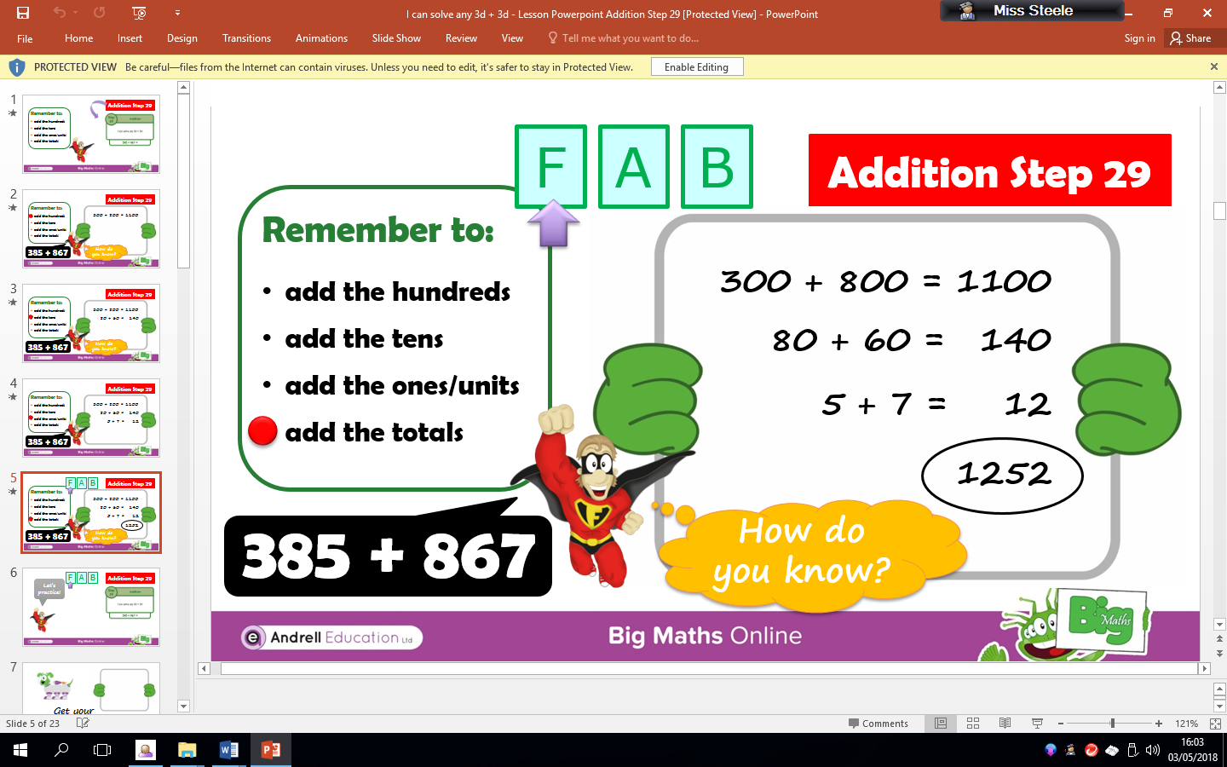3 digit plus 3 digit partitioning

This method is called partitioning and helps you add three digit numbers mentally. This will help children add numbers quicker and work it out in their head. Number bonds knowledge is key.

* Firstly, add the hundreds numbers, 300 + 800 = 1100
* Then add the tens numbers. 80 + 60 = 140. (Remember it is not 8 + 6)
* Finally add the units/ones numbers, 5 + 7 = 12.
* Then add all three totals together. 1100 + 140 + 12 = 1252.

Subtraction

Written methods – Borrowing/Exchanging.

Subtraction with Thousand, Hundreds, Tens and Units (Th, H, T, U)

|  |  |  |  |  |  |  |  |  |  |  |  |  |  |  |  |
| --- | --- | --- | --- | --- | --- | --- | --- | --- | --- | --- | --- | --- | --- | --- | --- |
|  |  |  | TH | H | T | U |  |  |  |  | TH | H | T | U |  |
|  |  |  | 9 | 7 | 8 | 5 |  |  |  |  | 6 | 2 | 45 | 14 |  |
|  |  | - | 3 | 5 | 2 | 1 |  |  |  | - | 2 | 1 | 3 | 6 |  |
|  |  |  | 6 | 2 | 6 | 4 |  |  |  |  | 4 | 1 | 1 | 8 |  |
|  |  |  |  |  |  |  |  |  |  |  |  |  |  |  |  |
|  |  |  |  |  |  |  |  |  |  |  |  |  |  |  |  |
|  |  |  |  |  |  |  |  |  |  |  |  |  |  |  |  |
|  |  |  |  |  |  |  |  |  |  |  |  |  |  |  |  |

Method

Example A-No borrowing/exchanging

1. Check the sign and ask, is it addition or subtraction?
2. Start with the units’ column (U). Subtract the 2 numbers. Write the answer under the units’ column.
3. Move to the tens’ column (T). Subtract the 2 numbers. Write the answer under the tens column.
4. Move to the hundreds column (H). Subtract the 2 numbers. Write the answer under the hundreds column.
5. Move to the thousands column (Th). Subtract the 2 numbers. Write the answer under the Thousands column.

Example B – Borrowing/exchanging

1. Check the sign and ask, is it addition or subtraction?
2. Start with the units’ column (U). Say “Is 4 smaller than 6, yes, so you have to borrow ten from the next column”. Go to the tens column put a line through 5 and make it a 4. Then take the 1 over to the 4 so it becomes 14. Now complete the sum 14 takeaway 6 which equals 8. Place this in the units column.
3. Move left to the tens column (T). Say “Is 4 smaller then 3, no, so complete the sum. Place the answer 1 in the tens column.
4. Move left to the Hundreds column (H). Say “is 2 smaller than 1, no, so complete the sum. Place the answer 1 in the hundreds column.
5. Move left to the Thousands column (Th). Say “is 6 smaller than 2, no, so complete the sum. Place the answer 4 in the thousands column.

Subtraction with Tens of Thousands, Thousand, Hundreds, Tens and Units (TTh,Th, H, T, U)

|  |  |  |  |  |  |  |  |  |  |  |  |  |  |  |  |
| --- | --- | --- | --- | --- | --- | --- | --- | --- | --- | --- | --- | --- | --- | --- | --- |
|  |  | TTH | TH | H | T | U |  |  |  | TTH | TH | H | T | U |  |
|  |  | 2 | 3 | 5 | 6 | 7 |  |  |  | 7 | 3 | 01 | 134 | 15 |  |
|  | - | 1 | 1 | 2 | 0 | 4 |  |  | - | 2 | 1 | 0 | 5 | 7 |  |
|  |  | 1 | 2 | 3 | 6 | 3 |  |  |  | 5 | 2 | 0 | 8 | 8 |  |
|  |  |  |  |  |  |  |  |  |  |  |  |  |  |  |  |
|  |  |  |  |  |  |  |  |  |  |  |  |  |  |  |  |
|  |  |  |  |  |  |  |  |  |  |  |  |  |  |  |  |
|  |  |  |  |  |  |  |  |  |  |  |  |  |  |  |  |

Method

Example A-No borrowing/exchanging

1. Check the sign and ask, is it addition or subtraction?
2. Start with the units’ column (U). Subtract the 2 numbers. Write the answer under the units’ column.
3. Move to the tens’ column (T). Subtract the 2 numbers. Write the answer under the tens column.
4. Move to the hundreds column (H). Subtract the 2 numbers. Write the answer under the hundreds column.
5. Move to the thousands column (Th). Subtract the 2 numbers. Write the answer under the Thousands column.
6. Move to the tens of thousands column (TTh). Subtract the 2 numbers. Write the answer under the Tens of Thousands column.

Example B – Borrowing/exchanging

1. Check the sign and ask, is it addition or subtraction?
2. Start with the units’ column (U). Say “Is 5 smaller than 7, yes, so you have to borrow ten from the next column”. Go to the tens column put a line through 4 and make it a 3. Then take the 1 over to the 5 so it becomes 15. Now complete the sum 15 takeaway 7 which equals 8. Place this in the units column.
3. Move left to the tens column (T). Say “Is 3 smaller then 5, yes, so you have to borrow a ten from the next column”. Go to the hundreds column put a line through 1 and make it a 0. Then take the 1 over to the 3 so it becomes 13. Now complete the sum 13 takeaway 5 which equals 8. Place this in the tens column.
4. Move left to the Hundreds column (H). Say “is 0 smaller than 0, no they are the same, so complete the sum. Place the answer 0 in the hundreds column.
5. Move left to the Thousands column (Th). Say “is 3 smaller than 1, no, so complete the sum. Place the answer 2 in the thousands column.
6. Move left to the Tens of Thousands column (TTh). Say “is 7 smaller than 2, no, so complete the sum. Place the answer 5 in the thousands column.

Subtraction with Hundreds of Thousands, Tens of Thousands, Thousand, Hundreds, Tens and Units (HTh, TTh,Th, H, T, U)

|  |  |  |  |  |  |  |  |  |  |  |  |  |  |  |
| --- | --- | --- | --- | --- | --- | --- | --- | --- | --- | --- | --- | --- | --- | --- |
|  | HTH | TTH | TH | H | T | U |  | HTH | TTH | TH | H | T | U |  |
|  | 5 | 1 | 41 | 0 | 5 | 8 |  | 89 | 910 | 91  0 | 910 | 91  0 | 10 |  |
| - | 3 | 1 | 3 | 0 | 1 | 5 | - | 7 | 9 | 5 | 4 | 2 | 3 |  |
|  | 2 | 0 | 1 | 0 | 4 | 3 |  | 1 | 0 | 4 | 5 | 7 | 7 |  |
|  |  |  |  |  |  |  |  |  |  |  |  |  |  |  |
|  |  |  |  |  |  |  |  |  |  |  |  |  |  |  |
|  |  |  |  |  |  |  |  |  |  |  |  |  |  |  |
|  |  |  |  |  |  |  |  |  |  |  |  |  |  |  |

Method

Example A-No borrowing/exchanging

1. Check the sign and ask, is it addition or subtraction?
2. Start with the units’ column (U). Subtract the 2 numbers. Write the answer under the units’ column.
3. Move to the tens’ column (T). Subtract the 2 numbers. Write the answer under the tens column.
4. Move to the hundreds column (H). Subtract the 2 numbers. Write the answer under the hundreds column.
5. Move to the thousands column (Th). Subtract the 2 numbers . Write the answer under the Thousands column.
6. Move to the tens of thousands column (TTh). Subtract the 2 numbers . Write the answer under the Tens of Thousands column.
7. Move to the hundreds of thousands column (HTh). Subtract the 2 numbers . Write the answer under the Hundreds of Thousands column.

Example B – Borrowing/exchaning

1. Check the sign and ask, is it addition or subtraction?
2. Start with the units’ column (U). Say “Is 0 smaller than 3, yes, so you have to borrow ten from the next column”. However, in this example you cannot borrow from 0, so you have to move to the hundreds of thousands column. Put a line through 9 and make it an 8. Then place a 1 in the tens of thousands column so it becomes 10.
3. You still cannot complete the sum so you need to borrow from the tens of thousands column, you put a line through the 10 and make it a 9. Then place a 1 in the thousands column so it becomes a 10.
4. You still cannot complete the sum so you need to borrow from the thousands column, you put a line through the 10 and make it a 9. Then place a 1 in the hundreds column so it becomes a 10.
5. You still cannot complete the sum so you need to borrow from the hundreds column, you put a line through the 10 and make it a 9. Then place a 1 in the tens column so it becomes a 10.
6. You still cannot complete the sum so you need to borrow from the tens column, you put a line through the 10 and make it a 9. Then place a 1 in the units column so it becomes a 10.
7. Now you can complete the sum. Go back to the units column say “is 10 smaller than 3, no, so complete the sum. Write the answer 7 in the units column. Move left to the tens column, say “is 9 smaller than 2, no, so complete the sum. Write the answer 7 in the tens column.
8. Move left to the hundreds column, say “is 9 smaller than 4, no, so complete the sum. Write the answer 5 in the hundreds column.
9. Move left to the thousands column, say “is 9 smaller than 5, no, so complete the sum. Write the answer 4 in the thousands column.
10. Move left to the tens of thousands column, say “is 9 smaller than 9, no they are equal, so complete the sum. Write the answer 0 in the tens of thousands column. Remind your child the importance of 0 as a place holder.
11. Move left to the hundreds of thousands column, say “is 8 smaller than 7, no, so complete the sum. Place the answer 1 in the Hundreds of Thousands column.

Mental Maths strategies-

Number bonds to 20 quick recall

Basic number bonds are critical foundations for maths and provide

the basis of a sound understanding of number which can be built on when learning new concepts. Playing mental maths games and answering mental arithmetic questions and repeating number bonds helps children to learn and become familiar with them. This makes progression in number work easier as the concepts get harder.

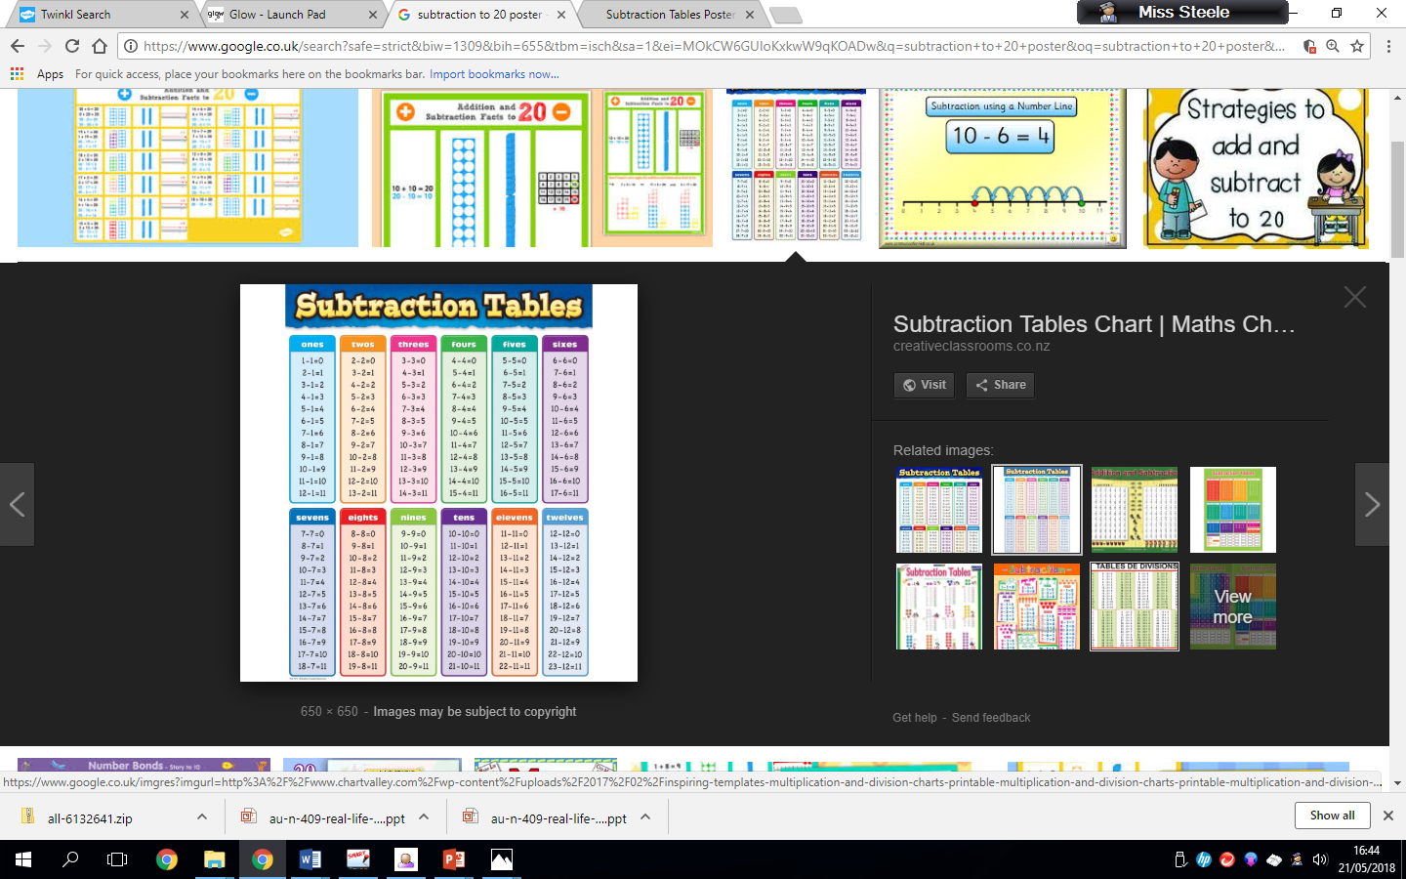

Find the Gap

This method is called finding the gap and helps you subtract mentally. This will help children subtract numbers quicker and work it out in their head. Number bonds knowledge is key.

Step 1

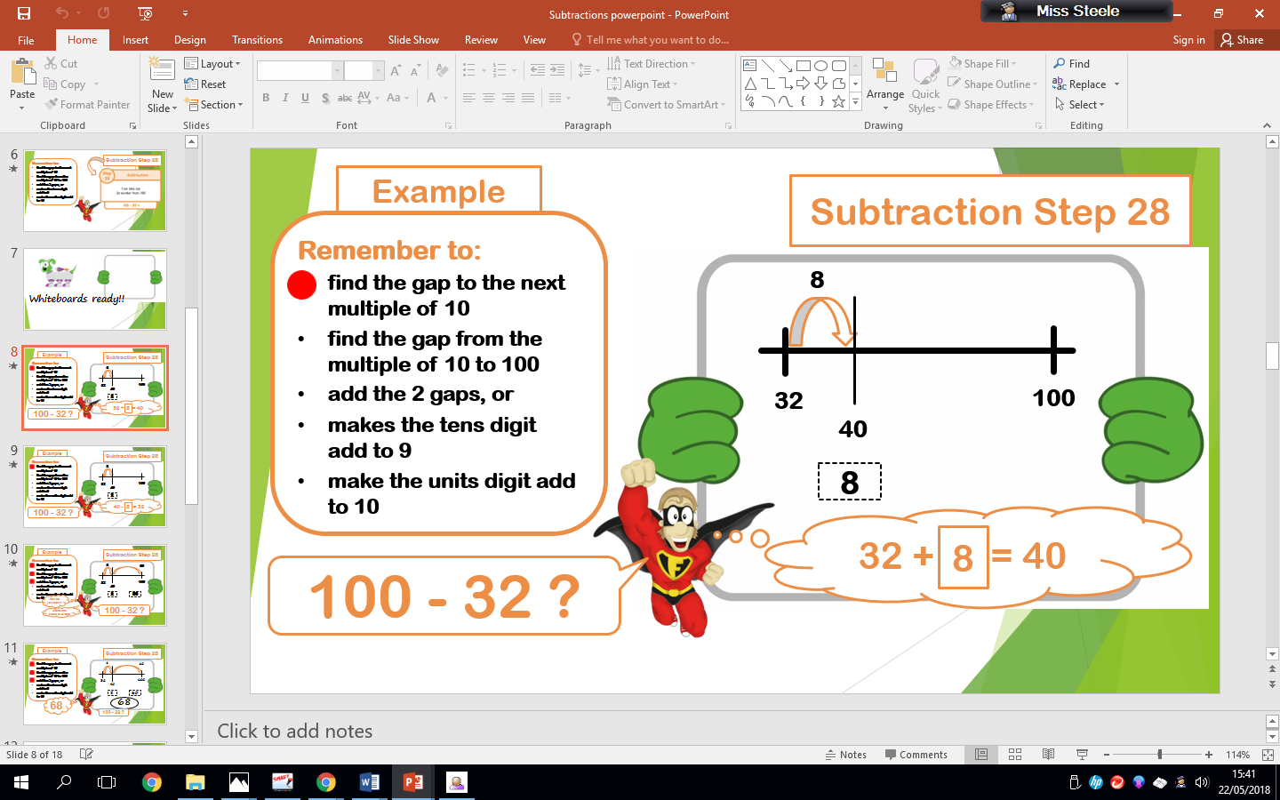

* Firstly, look at the number you are subtracting then find the gap from its next multiple of 10 e.g. the next multiple of 10 of 32 is 40 so you have added 8.

Step 2

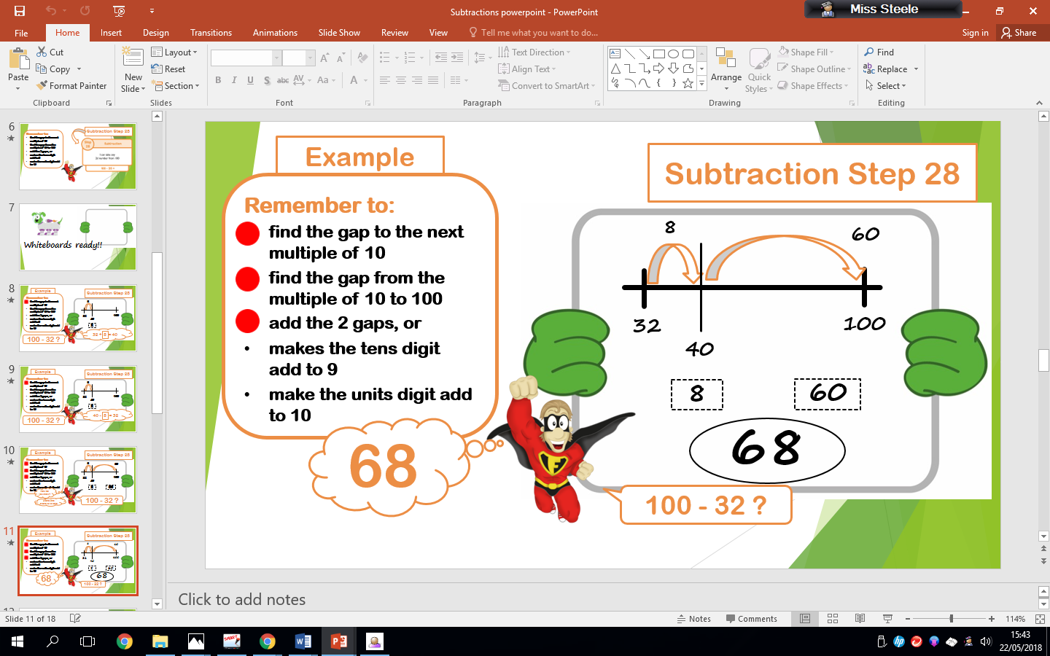

* Then, you have to find the gap from 40 to 100 which is 60. Then add the 2 gap numbers together e.g. 60 + 8 which equals 68.

Multiplication

Written methods

Multiplying with Thousand, Hundreds, Tens and Units (Th, H, T, U)

|  |  |  |  |  |  |  |  |  |  |  |  |  |
| --- | --- | --- | --- | --- | --- | --- | --- | --- | --- | --- | --- | --- |
|  | TTH | TH | H | T | U |  |  |  |  |  |  |  |
|  |  | 3 | 4 | 5 | 2 |  |  |  |  |  |  |  |
|  | x |  |  |  | 6 |  |  |  |  |  |  |  |
|  | 2 | 0 | 7 | 1 | 2 |  |  |  |  |  |  |  |
|  |  | 2 | 3 | 1 |  |  |  |  |  |  |  |  |
|  |  |  |  |  |  |  |  |  |  |  |  |  |
|  |  |  |  |  |  |  |  |  |  |  |  |  |
|  |  |  |  |  |  |  |  |  |  |  |  |  |

1. Check the sign and ask, is it addition, subtraction or multiplication?
2. Start with the units’ column (U). Say “6 times 2 equals 12”. Place the 2 in the units’ column and place the 1 under the tens column (T).
3. Move left to the tens’ column (T). Multiply the tens’ column, say “6 times 5 equals 30 plus the 1 you carried over equals 31”. Place the 1 in the tens column and the 3 under the hundreds column (H).
4. Move left to the hundreds column (H). Multiply the hundreds column, say ‘6 times 4 equals 24 plus the 3 I carried over, equals 27”. Place the 7 in the hundreds column and the 2 under the thousands (Th) column.
5. Move left to the thousands column (Th). Multiply the thousands column, say ‘6 times 3 equals 18 plus the 2 I carried over equals 20”. Write the 0 in the thousands column (Th) and the 2 in the tens of thousands (TTh).

REMEMBER! – always multiply each column first before adding any number you have carried over!

Multiplying with Tens of Thousands, Thousands, Hundreds, Tens and Units (TTh,Th H,T,U)

|  |  |  |  |  |  |  |  |  |  |  |  |  |  |  |
| --- | --- | --- | --- | --- | --- | --- | --- | --- | --- | --- | --- | --- | --- | --- |
|  | HTH | TTH | TH | H | T | U |  |  |  |  |  |  |  |  |
|  |  | 7 | 8 | 9 | 4 | 2 |  |  |  |  |  |  |  |  |
|  | x |  |  |  |  | 8 |  |  |  |  |  |  |  |  |
|  | 6 | 3 | 1 | 5 | 3 | 6 |  |  |  |  |  |  |  |  |
|  |  | 7 | 7 | 3 | 1 |  |  |  |  |  |  |  |  |  |
|  |  |  |  |  |  |  |  |  |  |  |  |  |  |  |
|  |  |  |  |  |  |  |  |  |  |  |  |  |  |  |
|  |  |  |  |  |  |  |  |  |  |  |  |  |  |  |

Method

1. Check the sign and ask, is it addition, subtraction or multiplication?
2. Start with the units’ column (U). Say “8 times 2 equals 16”. Place the 6 in the units’ column and place the 1 under the tens column (T).
3. Move left to the tens’ column (T). Multiply the tens’ column, say “8 times 4 equals 32 plus the 1 you carried over equals 33”. Place the 3 in the tens column and the 3 under the hundreds column (H).
4. Move left to the hundreds column (H). Multiply the hundreds column, say ‘8 times 9 equals 72 plus the 3 I carried over, equals 75”. Place the 5 in the hundreds column and the 7 under the thousands (Th) column.
5. Move left to the thousands column (Th). Multiply the thousands column, say ‘8 times 8 equals 64 plus the 7 I carried over equals 71”. Write the 1 in the thousands column (Th) and the 7 under the tens of thousands (TTh) column.
6. Move left to the tens of thousands column (TTh). Multiply the tens of thousands column, say ‘8 times 7 equals 56 plus the 7 I carried over equals 63”. Write the 3 in the tens of thousands column (TTh) and the 6 in the hundreds of thousands column (HTh).

REMEMBER! – always multiply each column first before adding any number you have carried over!

Multiplying with Hundreds of Thousands, Tens of Thousands, Thousands, Hundreds, Tens and Units (HTh,TTh,Th H,T,U)

|  |  |  |  |  |  |  |  |  |  |  |  |  |  |  |  |
| --- | --- | --- | --- | --- | --- | --- | --- | --- | --- | --- | --- | --- | --- | --- | --- |
|  | M | HTH | TTH | TH | H | T | U |  |  |  |  |  |  |  |  |
|  |  | 1 | 7 | 5 | 3 | 2 | 4 |  |  |  |  |  |  |  |  |
|  | x |  |  |  |  |  | 7 |  |  |  |  |  |  |  |  |
|  | 1 | 2 | 2 | 7 | 2 | 6 | 8 |  |  |  |  |  |  |  |  |
|  |  | 5 | 3 | 2 | 1 | 2 |  |  |  |  |  |  |  |  |  |
|  |  |  |  |  |  |  |  |  |  |  |  |  |  |  |  |
|  |  |  |  |  |  |  |  |  |  |  |  |  |  |  |  |
|  |  |  |  |  |  |  |  |  |  |  |  |  |  |  |  |

Method

1. Check the sign and ask, is it addition, subtraction or multiplication?
2. Start with the units’ column (U). Say “7 times 4 equals 28”. Place the 8 in the units’ column and place the 2 under the tens column (T).
3. Move left to the tens’ column (T). Multiply the tens’ column, say “7 times 2 equals 14 plus the 2 you carried over equals 16”. Place the 6 in the tens column and the 1 under the hundreds column (H).
4. Move left to the hundreds column (H). Multiply the hundreds column, say ‘7 times 3 equals 21 plus the 1 I carried over, equals 22”. Place the 2 in the hundreds column and the 2 under the thousands (Th) column.
5. Move left to the thousands column (Th). Multiply the thousands column, say ‘7 times 5 equals 35 plus the 2 I carried over equals 37”. Write the 7 in the thousands column (Th) and the 3 under the tens of thousands (TTh) column.
6. Move left to the tens of thousands column (TTh). Multiply the tens of thousands column, say ‘7 times 7 equals 49 plus the 3 I carried over equals 52”. Write the 2 in the tens of thousands column (TTh) and the 5 under the hundreds of thousands column (HTh).
7. Move left to the hundreds of thousands column (HTh). Multiply the hundreds of thousands column, say ‘7 times 1 equals 7 plus the 5 I carried over equals 12”. Write the 2 in the hundreds of thousands column (HTh) and the 1 in the millions column (M).

REMEMBER! – always multiply each column first before adding any number you have carried over!

Mental Maths strategies-

Times table facts

Basic times table facts are critical foundations for maths and provide the basis of a sound understanding of number which can be built on when learning new concepts. Playing mental maths games and answering mental arithmetic questions and repeating and reciting times table facts helps children to learn and become familiar with them. This makes progression in number work easier as the concepts get harder.

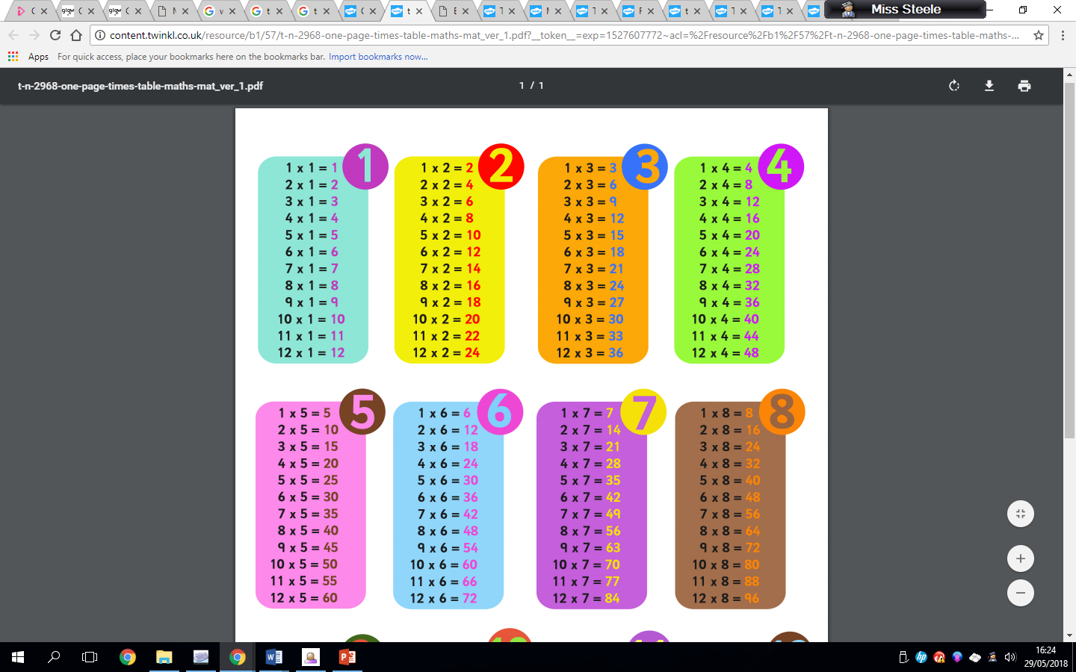

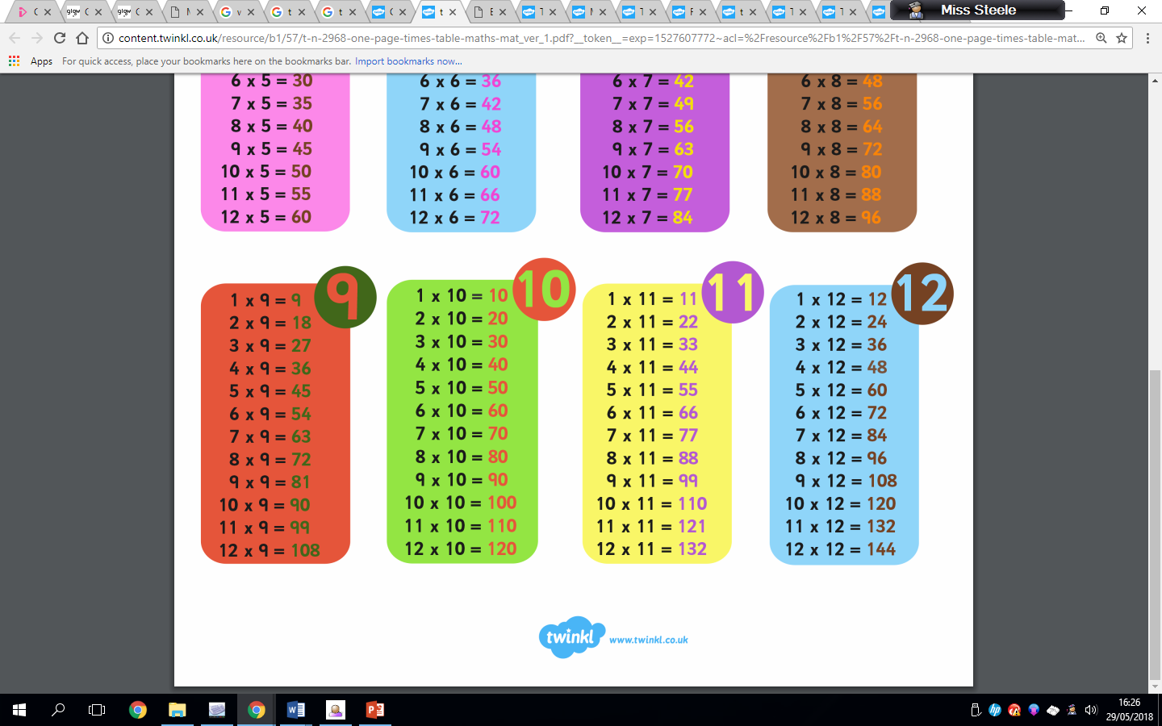

Mental maths games to support times tables

* **Finger Speed-Sums**   
  Students meet in pairs with one hand behind their back. On the count of three, they each put forward some number of fingers. Whoever says the sum first wins. Then the pair breaks up and each person finds a new person to play with. Advanced players can use two hands instead of just one.
  + **Times table snap.**
  + **Times table bingo.**
  + **Times table memory pairs.**
  + **Around the world**

Everyone sits in a circle. Select a quiz master and someone to start. The starting person stands behind another and the quiz master asks a random times table question. The one who answers correctly the fastest either moves on or swaps places with the person standing. Repeat until everyone has had a go.

* + **Ninja chop**

You need three people to play this game. One person to be the quiz master and two to play. The quiz master asks a random times table question and the players have to shout the correct answer whilst forming the numbers in the air with their hands.

Division

Written methods

Dividing [1]with Thousands, Hundreds, Tens and Units (Th, H, T, U)

|  |  |  |  |  |  |  |  |  |  |  |  |  |
| --- | --- | --- | --- | --- | --- | --- | --- | --- | --- | --- | --- | --- |
|  |  |  |  |  |  |  |  |  |  |  |  |  |
|  |  |  | 1 | 4 | 3 | 2 |  |  |  |  |  |  |
|  |  | 2 | 2 | 8 | 6 | 4 |  |  |  |  |  |  |
|  |  |  |  |  |  |  |  |  |  |  |  |  |
|  |  |  |  |  |  |  |  |  |  |  |  |  |
|  |  |  |  |  |  |  |  |  |  |  |  |  |
|  |  |  |  |  |  |  |  |  |  |  |  |  |
|  |  |  |  |  |  |  |  |  |  |  |  |  |

Example A – without remainders

1. Start with the biggest number column, in this example start in the Thousands column (Th). Say “2 divided by 2, how many 2’s are in 2?. There are 1. 1 goes on top of the line above the thousands column.
2. Move right to the hundreds’ column (H). Say “8 divided by 2. how many 2’s are in 8?. There are 4. 4 goes on top of the line above the hundreds’ column.
3. Move right to the tens column (T). Say “6 divided by 2. How many 2’s are in 6? There are 3. 3 goes on top of the line above the tens column.
4. Move right to the units column (U). Say “4 divided by 2. How many 2’s are in 4? There are 2. 2 goes on top of the line above the units column.

Dividing with Tens of Thousands, Thousands, Hundreds, Tens and Units (TTh,Th H,T,U)

|  |  |  |  |  |  |  |  |  |  |  |  |  |  |  |
| --- | --- | --- | --- | --- | --- | --- | --- | --- | --- | --- | --- | --- | --- | --- |
|  |  |  |  |  |  |  |  |  |  |  |  |  |  |  |
|  |  |  |  | 1 | 1 | 2 | 8 | 0 | r1 |  |  |  |  |  |
|  |  |  | 7 | 7 | 8 | 19 | 56 | 1 |  |  |  |  |  |  |
|  |  |  |  |  |  |  |  |  |  |  |  |  |  |  |
|  |  |  |  |  |  |  |  |  |  |  |  |  |  |  |
|  |  |  |  |  |  |  |  |  |  |  |  |  |  |  |
|  |  |  |  |  |  |  |  |  |  |  |  |  |  |  |
|  |  |  |  |  |  |  |  |  |  |  |  |  |  |  |

Example B – with remainders

1. Start with the biggest number column, in this example start in the Tens of Thousands column (TTh). Say “7 divided by 7, how many 7’s are in 7? There are 1. 1 goes on top of the line above the tens of thousands column.
2. Move right to the Thousands’ column (Th). Say “8 divided by 7. how many 7’s are in 8? There are 1 because 7 x1 = 7 with a remainder of 1. 1 goes on top of the line above the thousands column and carry the 1 remainder over to the 9 in the hundreds column.
3. Move right to the hundreds’ column (H). Say “19 divided by 7”. How many 7’s are in 19?. There are 2 because 7 x2 = 14 with a remainder of 5. 2 goes on top of the line above the hundreds’ column and carry the 5 remainder over to the 6 in the tens column.
4. Move right to the tens column (T). Say “56 divided by 7”. How many 7’s are in 56? There are 8 because 7 x8 = 56. 8 goes on top of the line above the tens column with no remainder.
5. Move right to the units column (U). Say “1 divided by 7. How many 7’s are in 1? There are none because 7 x 0 = 0 with a remainder of 1. 0 goes on top of the line above the units column and write the remainder 1 to the right hand side (r 1).

Mental Maths strategies-

Division facts

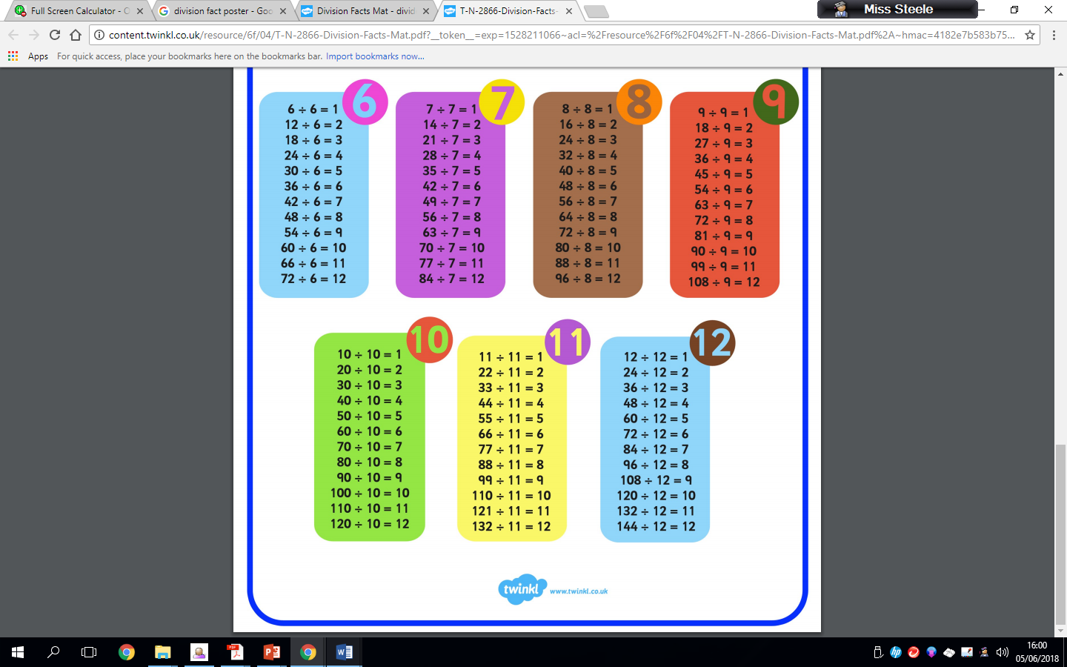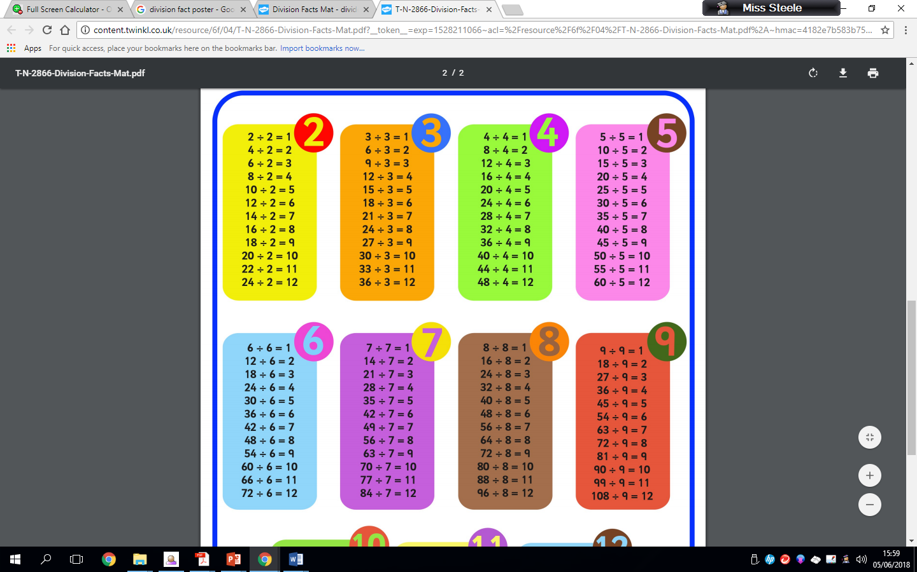Basic times table/division facts are critical foundations for maths and provide the basis of a sound understanding of number which can be built on when learning new concepts. Playing mental maths games and answering mental arithmetic questions and repeating and reciting times table/division facts helps children to learn and become familiar with them. This makes progression in number work easier as the concepts get harder

Mental maths games to support times tables

* **Finger Speed-Sums**   
  Students meet in pairs with one hand behind their back. On the count of three, they each put forward some number of fingers. Whoever says the sum first wins. Then the pair breaks up and each person finds a new person to play with. Advanced players can use two hands instead of just one.
  + **Division snap.**
  + **Division bingo.**
  + **Division memory pairs.**
  + **Around the world**

Everyone sits in a circle. Select a quiz master and someone to start. The starting person stands behind another and the quiz master asks a random division question. The one who answers correctly the fastest either moves on or swaps places with the person standing. Repeat until everyone has had a go.

* + **Ninja chop**

You need three people to play this game. One person to be the quiz master and two to play. The quiz master asks a random division question and the players have to shout the correct answer whilst forming the numbers in the air with their hands.

Fact Families

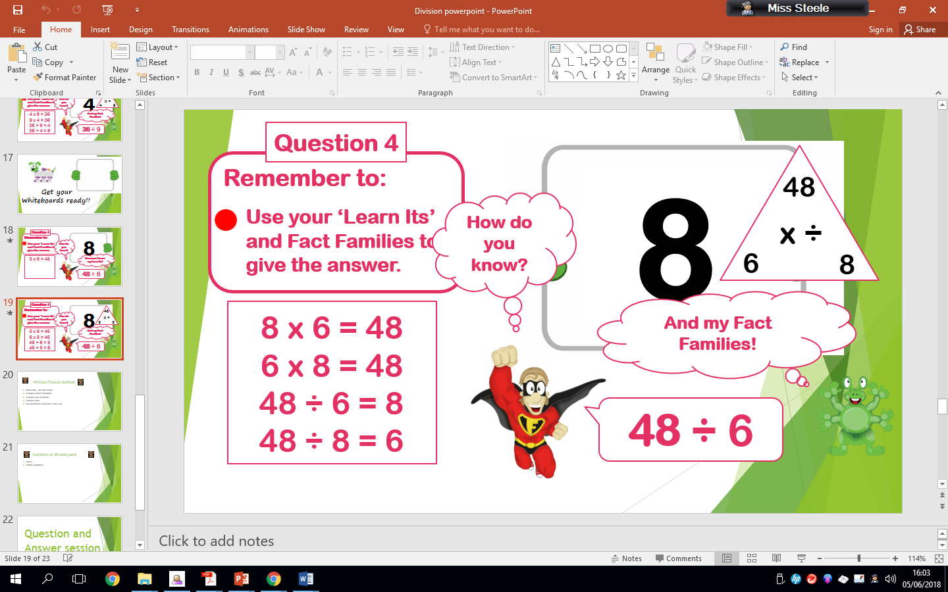

To solve 48 divided by 6 children should use their ‘Learn its’ and Fact Families to give the answer. The children should be aware that there are 4 facts for each division statement, 2 of which are multiplication and 2 of which are division. E.g. the fact families of 48 divided by 6 are 8 x 6 = 48, 6 x 8 = 48, 48 divided 6 = 8 and 48 divided 8 = 6.

1.