Cairns Primary School, Nursery and ASN Class

Standards and Quality Report

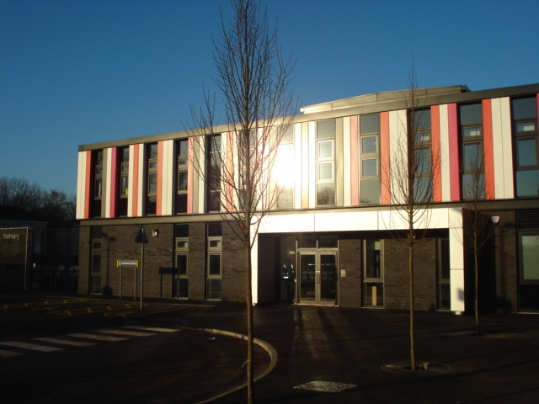

Session 2017/18

Cathkin Learning Community
School Name: Cairns Primary School, ASN Dept and Nursery Class

Context of the school:
Cairns Primary is situated in the Halfway area of Cambuslang. The immediate local area is predominantly social housing with some privately owned accommodation on the outskirts of our catchment area. Cambuslang is a developing area and our catchment has been ‘re-zoned’ several times over the past few years to accommodate the growing number of families moving into new build private housing in the wider community. This has also increased the number of catchment secondary schools available for our P7 pupils.
Our current roll, as of June ’18, is 291 pupils over 3 ASN classes and 11 mainstream classes. In addition to catering for P1-P7 pupils, Cairns has an excellent Nursery facility with capacity to provide 40 morning and 40 afternoon places for early learning and childcare. We currently have 74 children at our nursery, bringing our total school role for session. 2017-18 to 365 pupils.
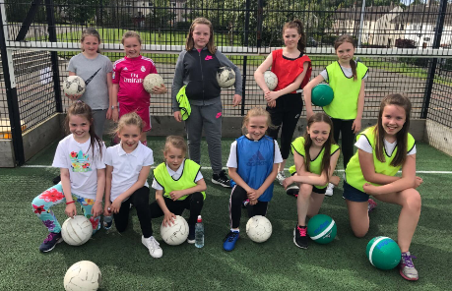
Cairns Primary was established in 1957, however, we moved into our new, 'state of the art' school building in February 2012. This provides an excellent, modern environment in which our children can learn and achieve.
As a school we have developed our vision statement, ‘Lead, Learn, Aspire, Achieve,’ to reflect how we feel about our school and our learning. We believe everyone has the right and the potential to be leaders in their own learning and to aspire to achieve to be the best they can be. As a school we have chosen four core values; love, friendship, honesty and trust. We promote positive relationships within the school and foster an ethos which encourages all pupils to respect themselves and others.
Stage | P1 | P2 | P3 | P4 | P5 | P6 | P7
% of pupils living in SIMD 1 and 2 | 81% | 51% | 40% | 53% | 45% | 55% | 42%
In session 17/18, of our roll of 291 school pupils, 49% lived in a home within SIMD 1 or 2 and 31% of our school pupils were in receipt of Free School Meals. Children living within SIMD 1 and 2 are present in all stages, although as you can see there is a higher proportion in this session’s P1, P2, P4, and P6 cohorts.
The staffing situation at Cairns has been extremely challenging over the past few years with turnover of staff being high, mainly due to maternity leaves, long term absences, NQT’s and role increase resulting in temporary staff filling vacancies. In session 2018/19, staffing continues to be challenging. We have 4 members of staff on maternity leave, two of whom are in our Senior Leadership Team (SLT). We also have a number of staff who will be going on maternity leave at different points across the session. We have an active and engaged Parent Council who play an integral role in school life. We work hard as a school community to engage with our wider Parent Forum to ensure strong partnership working. We are proud to be an integral part of the Cairns community and are keen to work in partnership with the local community and our partners within the Cathkin Learning Community. We have developed strong links with our neighbours at St Cadoc’s Primary and are ‘Champions for Change’ schools developing many joint projects. We have also developed strong links with our local nursery partners and secondary schools, to ensure positive and smooth transitions are planned.

The National Context for Education
The National Improvement Framework (NIF) for Scottish Education sets out the Scottish Government’s vision to continually improve Scottish Education and to close the attainment gap, delivering both excellence and equity. Our school, working in partnership with South Lanarkshire Council is fully committed to delivering these ambitious aims.
The key priorities of the National Improvement Framework are:
- Improvement in attainment, particularly in literacy and numeracy
- Closing the attainment gap between the most and least disadvantaged children
- Improvement in children and young people’s health and wellbeing
- Improvement in employability skills and sustained, positive school leaver destinations for all young people

Key drivers of improvement have also been identified, these are:
- School leadership.
- Teacher professionalism.
- Parental engagement.
- Assessment of children’s progress.
- School improvement.
- Performance information.

South Lanarkshire Council’s overall vision is to “improve the quality of life of everyone in South Lanarkshire Council.”
Education Resources’ key purpose is to:
“Raise achievement and attainment, inspire learners, transform learning and work in partnership to strengthen our communities”
The priorities relating to this are:
- Deliver high-quality early learning and childcare to give our children the best educational start
- Raise standards in literacy, numeracy and close the poverty-related attainment gap.
- Improve health and wellbeing to enable children and families to flourish.
- Support children and young people to develop their skills for learning, life and work.
- Ensure inclusion and equality are at the heart of what we do.

Our school is committed to taking these priorities forward and developing each driver through our annual School Improvement Plan (SIP).

Assessment of children’s progress throughout the Broad General Education (to end of S3)
As one of the drivers, our school, alongside all schools in Scotland, has been required to report on Curriculum for Excellence levels for literacy and numeracy achieved by all children at the end of stages P1, P4, P7 and S3. This data is submitted to South Lanarkshire Council in June each year and collected subsequently by the Scottish Government. This data is based on teacher judgement, informed by a wide range of assessment evidence including standardised testing where appropriate. As from session 2016/17, all schools in Scotland will be required to participate in the new Scotland National Standardised Assessment (SNSA) project. This will further help inform teacher judgement of levels.
The following table shows benchmarks for children achieving Curriculum for Excellence Levels.
Level | Stage covering 3 years approx.
Early | The pre-school years and P1, or later for some.
First | To the end of P4, but earlier or later for some.
Second | To the end of P7, but earlier or later for some.
Third and Fourth | S1 to S3, but earlier for some.  The fourth level broadly equates to Scottish Credit and Qualifications Framework level 4.  The fourth level experiences and outcomes are intended to provide possibilities for choice and young people’s programmes will not include all of the fourth level outcomes.
Senior phase | S4 to S6, and college or other means of study.

Some children and young people will start learning at these levels earlier and others later, depending upon individual needs and abilities. Many children not attaining National Levels will have an Additional Support Plan (ASP) and may be making good progress, but against different milestones e.g. individual targets. Learning progress is not about how fast children move through the levels but about ‘how much’ and ‘how well’ children learn, having depth and breadth of experiences at each level.
Assessment of these levels is based on a wide variety of evidence and ways of measuring progress such as assessment of projects, general class work, observations and peer assessment. Where possible, children and young people are encouraged to be directly involved in the assessment process.
Schools and teachers work with others to set shared standards for assessing progress. These standards are based on National “benchmarks” for each area of the curriculum. This process is called moderation and it ensures that schools have similar expectations.
What follows is our school’s data about achievement of these levels for session 15/16 through to session 17/18.

Review of SIP progress session ________2017/2018____________

Priority 1: Improve attainment for all pupils in literacy with a particular focus on differentiation and assessment in writing.

National Improvement Framework Key Priorities  - Improvement in attainment, particularly in literacy and numeracy;  - Closing the attainment gap between the most and least disadvantaged children;  - Improvement in children and young people’s health and wellbeing; and  - Improvement in employability skills and sustained positive school leaver destinations for all young people. | National Improvement Framework Key Drivers  - School leadership  - Teacher professionalism  - Parental engagement  - Assessment of children’s progress  - School improvement  - Performance information
HGIOS 4 QI: 1.1, 2.2, 2.3, 2.5, 3.2

Progress and Impact:
Literacy

Progress this session included;
- Enhancing literacy programme to include new literacy materials to support reading.
- Investing in training in the new Active Literacy Approach to reading.
- Continuing to support our less able readers - most of whom were in our targeted groups - with one to one interventions such as the 5-minute box.
- Extra-curricular club to support learners with literacy difficulties.
- Continuing with our commitment to provide every class with a support assistant during formal writing sessions.
- Look at whole school interventions to encourage pupils in a real life context and develop family connections.
Impact
For Literacy interventions, all children enthusiastically engaged in their learning. Staff reported that they felt all learners’ confidence improved as the weeks progressed and they enjoyed the consistency of the teaching approaches.
Staff reported the aid of a support assistant during formal writing sessions helped to ensure lessons were more robust and support could be given to more pupils. The Cairns Writing approach allows feedback to be given to pupils on a regular basis and pupils reported this as being a positive way for them to improve their writing skills.
Literacy interventions saw all pupils involved making progress in their reading skills and abilities - with their reading ages increasing. These will continue next session. Currently we have two support assistants trained to carry out the 5 min box. We would like to increase the amount of staff we have trained to provide support across the infant stages of the school.
Next Steps:
- Develop Active Literacy Approaches in P1-3.
- Ensure all staff attend Active Literacy Training- P1-7 in term 1.
- Book Band all P1-3 Books to assist in development of programme
- Deliver training to staff on Cairns Writing Approach and revised planning and assessment tools.
- Roll out intervention programmes using ‘5 min boxes’ to targeted pupils.
- Continue to further enhance our Paired Reading Programme in 2018/19.

Priority 1: Improve attainment for all pupils in numeracy with a particular focus on pace, challenge, differentiation and assessment.

National Improvement Framework Key Priorities  - Improvement in attainment, particularly in literacy and numeracy;  - Closing the attainment gap between the most and least disadvantaged children;  - Improvement in children and young people’s health and wellbeing; and  - Improvement in employability skills and sustained positive school leaver destinations for all young people. | National Improvement Framework Key Drivers  - School leadership  - Teacher professionalism  - Parental engagement  - Assessment of children’s progress  - School improvement  - Performance information
HGIOS 4 QI: 1.1, 2.2, 2.3, 2.5, 3.2

Progress and Impact:

Numeracy- Progress this session included;

- Further developing our approaches to mental maths to secure children’s mental ability to calculate simple number bonds through the ‘Big Maths’ programme.
- Evaluate and supplement resources to allow each class to have a ‘toolkit’ of supplies to enhance and support teaching and learning.
- Enhance the maths curriculum with the use of digital technology.
- Engage parents more in supporting maths and numeracy- pilot programme of workshops delivered to P6 stage and packs of support material sent home to all pupils.

Impact
Staff observed increased engagement of pupils in mental maths and changes in weekly scores.
Prior to the interventions, 74% of children reported they didn’t enjoy mental maths and/or found it difficult to do. This was especially prevalent in our targeted groups. Following 8 months of consistent ‘Big Maths’ work in class, 87% of pupils said they enjoyed mental maths and named ‘Big Maths’ activities, such as ‘click its’ as helping them develop their skills in mental maths.
On discussions with staff and pupils, the general approach to maths has improved as staff now have all resources available to carry out practical aspects of lessons.
Pupils are more motivated to participate in maths lessons and results demonstrate an improvement in maths and numeracy.
Things are better for all pupils but particularly those in the targeted groups. In the year groups improvements have been made since October. In October, 60% of p5 pupils in our targeted group were on track with numeracy - in March ’18 this rose to 67%. In October, 23% of our P6 pupils in our targeted group were on target, this rose to 64% in March ’18.

Next Steps:
- Continue to embed ‘Big Maths’ approaches in all classes.
- Develop use of Progression Pathways planners to ensure pace and challenge.
- Roll out our parental engagement programme of maths workshops.
- Participate for the second year in the Collaborative Action Research project around improving maths and numeracy skills for pupils at P4 with colleagues from SLC, NLC and Glasgow University.
- Roll out revised maths planners giving staff increased confidence in planning and assessing using the Benchmarks.
- Continue to implement targeted interventions with identified pupils to improve core maths and numeracy skills.

Priority 2: Close the attainment gap between the most and least disadvantaged children in literacy.
National Improvement Framework Key Priorities  - Improvement in attainment, particularly in literacy and numeracy;  - Closing the attainment gap between the most and least disadvantaged children;  - Improvement in children and young people’s health and wellbeing; and  - Improvement in employability skills and sustained positive school leaver destinations for all young people. | National Improvement Framework Key Drivers  - School leadership  - Teacher professionalism  - Parental engagement  - Assessment of children’s progress  - School improvement  - Performance information
HGIOS 4 QI: 1.1, 2.2, 2.3, 2.5, 3.2

Activity Summary
Literacy- Progress this session included;
- Staff training- teaching staff and support staff engaged in training to up-level skills.
- Training for P7 Reading buddies, where time was allocated in the school timetable for a consistent approach.
- Regular sessions carried out with pupils, with feedback sought regularly.
- Time allocated for support staff to regularly communicate with class teachers and identify next steps in the children’s learning.
- Pupil Voice workshops.
- Learning targets linked to Personal Learning Plans.
- Interventions with targeted children monitored and evaluated to track progress of pupils and impact of intervention.
- Professional dialogue with support staff and SLT to discuss and monitor progress.

Impact
Almost all of the P2-3 pupils achieved their target;
P2- 83% of pupils achieved target.
P3- 67% of pupils achieved target.
50% of the group of pupils who achieved, exceeded the target and made a year’s progress in their reading age within a six-month period.
Our Paired Reading intervention was successful;
Target Group – P4 pupils (11)
75% of pupils achieved target.
From the group of children who achieved the school target, many made significant gains in their reading ages in the 6-month period.
(i) 25% made progress > than 1 year.
(ii) 25% made progress of >1.5 years.
(iii) 25% made progress of >1.8 years.
From (iii) one child made an improvement of 2.4 years in the 6-month period
Next Steps
- Roll out intervention programmes using ‘5 min boxes’ to targeted pupils.
- Investigate opportunities for staff to participate in the Catch up Literacy Programme.
- Provide Dyslexia Toolkit training for all staff.
- Continue to further enhance our Paired Reading Programme in 2018/19.
- Use PEF funding to purchase an additional teacher to reduce class sizes.
- Use PEF funding to purchase an additional Support Member of staff to help provide interventions.
- Provide in-house training for staff in various literacy approaches and opportunities to visit other establishments to observe Active Literacy and engage in professional dialogue to enhance their practice.

Priority 2: Close the attainment gap between the most and least disadvantaged children in numeracy, with a particular focus within p4-6.

National Improvement Framework Key Priorities  - Improvement in attainment, particularly in literacy and numeracy;  - Closing the attainment gap between the most and least disadvantaged children;  - Improvement in children and young people’s health and wellbeing; and  - Improvement in employability skills and sustained positive school leaver destinations for all young people. | National Improvement Framework Key Drivers  - School leadership  - Teacher professionalism  - Parental engagement  - Assessment of children’s progress  - School improvement  - Performance information
HGIOS 4 QI: 1.1, 2.2, 2.3, 2.5, 3.2

Activity Summary
Numeracy- Progress this session included;
- Commitment to ‘Catch up Maths’ and ‘5 Minute Box’ maths interventions for targeted groups in P4, P6 and P7.
- Whole School Maths Open Evening was very well attended with different sessions for infant and upper school.
- Primary 6 Parent Afternoon Workshops
All parents invited to workshops on maths learning, led by teachers and pupils. Phone invites made to a targeted group of parents within SIMD 1&2.
  - A targeted group of parents were given both letter and telephone invites to maths workshops.
  - Workshops included basic numeracy concepts, where teaching methods used with pupils and activities for parents to participate in were carried out.
  - Additional concepts suggested by parents were also undertaken within these 4 afternoon sessions.
  - A bag of maths resources and games were distributed for all primary 6 parents. The targeted group of parents were given specific teaching and dialogue with regards to how to use the resources with their children.
Impact
- Maths open evening was very well attended from the general population of the school.
- Turnout from the targeted group of parents was 80%.
- Maths resource bags for home use were taken from all who attended and requested by some of those who could not attend.
- On average 7/8 targeted parents attended the 4 afternoon workshops.
- 100% of the parents in attendance stated that the work carried out had furthered their own maths/numeracy understanding.
- 100% of parents reported that the workshops would definitely aid the numeracy work that they carried out with their children at home.

Improvement Planning Parent Maths Group –
- Volunteers sought from the Parent Council to undertake discussions on improvement planning in maths.
- Parents met with 3 staff members of the Leadership Team to discuss maths resourcing and teaching as it currently stands and improvement planning for next year, directly feeding into the School Improvement Plan 2018/19.
- Information boards and request for Parental feedback was sought at March 2018 parents evening.

Impact
We have a very active Parent council who are representative of all stages in our school.
Ten parents, from a group of eighteen at the parent council, volunteered to be part of the Improvement planning group. 70 % of these parents attended the meeting with regards to school improvement of numeracy / maths.
100% from this meeting agreed that sharing and developing school improvement priorities in this way was beneficial.

Collaborative action Research Project-
Raising Attainment in Maths and Numeracy in P4 using Catch Up Maths as the key intervention.
Our P4 pupils and staff participated in a Collaborative Action Research Project with staff from other SLC comparator schools and identified schools from NLC. We used ‘Catch up Maths’ as a key intervention strategy.

Impact
During the implementation of the Catch-Up intervention, class teachers noted a considerable change in the learners’ attitude and focus when returning from individual sessions. The class teachers noted that learners were more confident when answering out in class and that they were more willing to tackle class work. It was noted that on many occasions the layout of some learners’ work had improved and that accuracy and understanding of concepts was better.
The children themselves, stated that they enjoyed coming out of class for the Catch – Up sessions because they could focus in the quiet space and that they felt like they were getting better at lots of different concepts. The children in the initial 2 target groups are progressing well through the programme and continue to make improvements in their learning. These improvements are tracked throughout the sessions and routinely feedback to the relevant class teachers.

Priority 3: Develop robust tracking and monitoring systems, which lead to an improvement in children and young people’s health and well-being through a focus on nurture.

National Improvement Framework Key Priorities  - Improvement in attainment, particularly in literacy and numeracy;  - Closing the attainment gap between the most and least disadvantaged children;  - Improvement in children and young people’s health and wellbeing; and  - Improvement in employability skills and sustained positive school leaver destinations for all young people. | National Improvement Framework Key Drivers  - School leadership  - Teacher professionalism  - Parental engagement  - Assessment of children’s progress  - School improvement  - Performance information
HGIOS 4 QI: 1.1, 1.4, 2.2, 2.3, 2.4, 2.5, 2.7, 3.1, 3.2

Progress this session;
A nurture room was established following an identified need for targeted support for individual pupils and groups of children. This Health and Wellbeing support was designed to take groups of children for nurture sessions to support social and emotional needs, self-esteem and confidence and to support P7 transition. It was hoped that this would have a positive impact on the pupils’ learning experiences within class.
3 groups were identified by staff and SLT –a Primary 2 group, a Primary 3-4 group and a Primary 5-7 group.
The same Health and Wellbeing resources were purchased for use within all classes. The 3 groups of children had targets set using the Boxall profile and the work undertaken at their sessions focussed on activities designed to have a positive impact on the above outcomes.
This in turn was designed to hopefully allow the pupils to transfer these skills in to their time in class, within their family and within the local community.
The nurture room was established in the following way:
- Staff training in nurture
- Pupils identified by staff and SLT
- Parents invited in for information, consultation and questions
- Staff awareness of nurture and its progress addressed and discussed at staff meeting
- Resources purchased for nurture and room established and designed
- Boxall profile assessments carried out
- Sessions of nurture carried out with pupils
- Parents invited in to final session to take part in activities with their child and obtain feedback
- Children taken on outing to celebrate their achievements and to allow them to practice the social skills learned at nurture sessions.

Impact:
The children completed evaluations on their last nurture session of this term to identify strengths and areas for development.
Staff were consulted to establish how successful nurture had been and if this had a positive impact on the learning taking place in class.
Staff reported –
Children were excited and motivated by nurture sessions
‘Minor ailments’ were reduced on nurture days
Children were talking about nurture and looked forward to sessions.
Parents reported their child was talking about nurture at home and were engaged
Staff were keen to find out what their pupils were doing at nurture and how they could support them in class.
Next Steps:
- Provide training for all staff on ‘Nurture Talks’ and develop a whole school approach to Nurture Principles.
- Facilitate training for interested staff.
- Engage with other professionals and school staff to further develop the nurture class to provide support for identified pupils.
- Provide training for all staff on Boxall Profiles.
- Review Health and Wellbeing curriculum.

  - Attainment data - Attainment of Literacy Curriculum for Excellence levels 2015/16, 2016/17 and 2017/18 (teacher judgement).

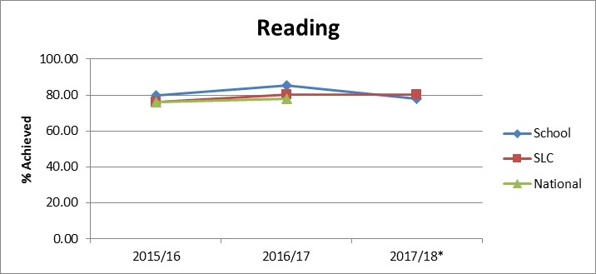

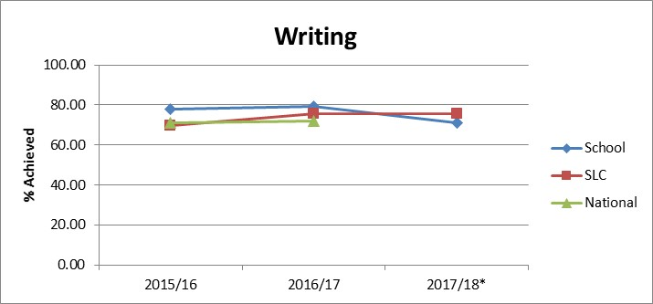

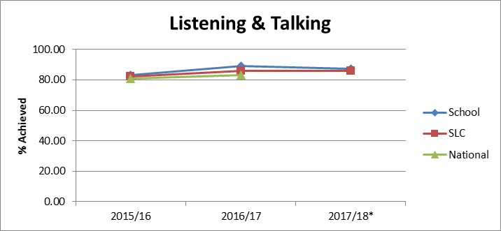

  - Attainment data - Attainment of Numeracy Curriculum for Excellence levels 2015/16, 2016/17 and 2017/18 (teacher judgement).

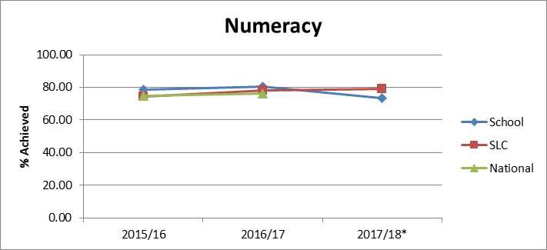

Achieving Excellence: Overall Progress towards National Improvement Framework Priorities
Session 2017-18
Use all available evidence (including data)

Literacy:
Progress | satisfactory | good | very good | excellent
 |  | X

Strengths
- Our data and other evidence shows that in session 2017/18, 81% of our pupils from P1- P7 were reading at, or above their chronological reading age.
- Our evidence has shown us that, the new adaptations we have made to our assessment of writing has led to more robust marking based on revised criteria.
- Staff’s confidence in assessing progress using assessment tools, and their own professional judgement, is increasing and this is something we will continue to build on.
- New strategies and interventions we have implemented this session have been successful and have helped to close the gap for many of our pupils.

Next steps

- Our three year trend of progress shows that we have made good progress this year in most areas and we hope to build on this next session. The attainment data for P1 ,4 and 7 show a dip in attainment for these stages. Levels of SIMD across the school are higher than previous sessions and we are confident our interventions over the next few sessions will allow more comparative data to show improvement. In terms of children in receipt of Free School Meals, we still have work to do in terms of closing the attainment gap, however many of the initiatives we have implemented this session have made a positive impact with many targeted pupils exceeding their predicted targets. Continuing and developing these interventions is a key priority for our PEF spending this year and we will be targeting these children and continuing to monitor their progress carefully to ensure interventions are appropriate and effective.
- We have further reviewed and revised our approaches to teaching and assessing writing. We have noticed an overall improvement in the skills of writing, however this is an area we will be focussing on again to ensure high quality teaching and learning for all. We will be engaging in moderation activities around our new assessment criteria to ensure confidence and consistency.

Numeracy:
Progress | satisfactory | good | very good | excellent
 |  | X

Strengths

- Our data and other evidence shows that in session 2017/18, as a school P1-7, we have raised attainment by almost 10%. This is something we will continue to develop and improve on.
- We have introduced a more consistent approach to assessment in maths and numeracy across the school and this helps us to measure progress and identify areas for improvement more effectively.
- Our maths working party have worked hard to ensure consistency of approaches in teaching and learning of maths and numeracy and have provided support material and revised planners and assessment material, as well as training to all staff.
- Interventions targeting our P4 pupils this session, which was a stage we observed had previously seen a dip in attainment, have made a great difference with almost 80% of pupils secure in their learning at first level.
Next steps
- The average across P1, 4 and 7 shows there has seen a slight dip in attainment. This is an area we are aware of and will be addressing this year.
- We will be targeting our P4-P7 stages again for interventions this session. Using information and consulting with parents and pupils, we hope to improve our attainment levels for all stages of the school.
- Roll out our parent workshops and activity packs to targeted stages across the school.
- Hold more parental workshops looking at maths and numeracy activities which parents and carers can engage in to support their children.
- Our evidence from the last two sessions has allowed us to identify where progress has been made and where we have areas of development - we will continue to use this information to plan further improvement.

In terms of children in receipt of Free School Meals, we still have work to do in terms of closing the attainment gap. This is a key priority for our PEF spending this year and we will be targeting these children and monitoring their progress carefully to ensure interventions are appropriate and effective.

Health and Wellbeing
Progress | satisfactory | good | very good | excellent
 |  | x

Strengths
- The development of our nurture class with workshops for targeted pupils has been successful and will be further developed next session.
- The interest from staff has been superb and this has encouraged us to look further at a nurturing schools approach next session to build on our existing good practice.
- Our Health and Wellbeing curriculum provides progressive learning opportunities for all pupils. We have developed curricular planners for all areas of HWB to ensure children are developing their physical, emotional and social wellbeing. Personal Learning Plans completed by all pupils have a Health and Wellbeing focus with specific targets each term, as well as pupils regularly self-assessing themselves using the SHANARRI indicators.
- Our Values programme focuses on Honesty, Friendship, Love and Trust. These are integral to our HWB programme and events for pupils and families reinforce these core values. An annual health week helps to compound the learning within all aspects of HWB.
- Our policy on Promoting Positive Relationships and behaviour, with a focus on rights and responsibilities, continues to foster a restorative approach to behaviour and is tracked and monitored throughout the year. Parents are involved in this process. We have had no exclusions this year. Our whole school average attendance is >95%.

Next steps

- We will further develop the use of our nurture room to best support targeted pupils.
- Health and Wellbeing resource boxes will be present in every class to allow high quality teaching and learning experiences for our pupils.
- Training for all staff on ‘Nurture Talks’ and Nurture principles will be provided.
- We have a number of pupils, especially in P1-7 who have complex social and emotional needs which are acting as barriers to their learning. We will be implementing a number of interventions to support these pupils.
- We will be reviewing and revising our anti-bullying policy with all stakeholders and holding workshops for parents and pupils around cyber bullying and online safety.
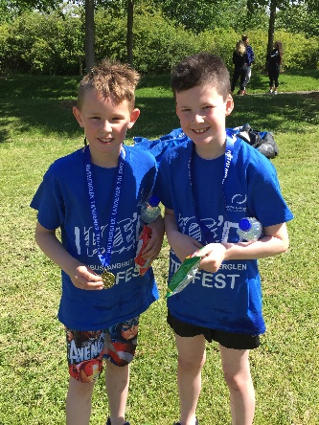
Employability Skills/Positive Destinations
satisfactory | good | very good | excellent
 | X

Strengths
- We have our own ‘Masterclass’ skills programme, which over the last session has been developed to include our infant department.

Next steps
- Review and further develop our Masterclass programme and continue to build links with Cathkin High School and DSYW.
- Create more links with local business partners and ensure existing partners are more involved in initiatives held in school, e.g World of Work Day.
- Develop a system to track skills and incorporate this in the children’s PLP’s and ROA folders.

Overall quality of our learners’ achievements
Highlights of session 2017-18
We have had a very busy and productive session. Children at all stages continued to receive a broad, balanced and well planned curriculum in line with Curriculum for Excellence. All staff have been engaged in professional discussion and debate around the new benchmarks. We have developed maths, numeracy and writing planners in line with the benchmarks and all staff are engaging with these national standards in all areas of the curriculum.

All pupils benefitted from participating in the wide range of skills based activities which were provided by our Masterclass programme. All pupils were involved in school committees this session and ‘Pupil voice’ was a key focus for all groups. Our Pupil Council, Health Promoting Schools Committee and Eco Committee have been busy fundraising for our local Foodbank and other charities, through our French Café initiative, focused themed days and other activities which were all decided upon and planned by our pupils.

We continued to build on our ‘Champions for Change’ work with St Cadocs and again led a successful joint project for our P7 pupils from both schools, looking at sectarianism within society.

We have had many highlights this year. All classes presented showcases and assemblies for the school and their parents. Our Christmas Nativity was a great success with our P1 pupils highlighting their confidence and talent. Our P7 pupils held, and led, a Burns Supper for over two hundred guests, following on from the amazing success of our school as overall winners of the Bridgeton Burns Club school’s competition, for the second year running. Many of our pupils from P1-7 participate in this established competition, and this was a fantastic achievement for our school. Prize money from the competition was used to take those who participated and our P7 pupils to visit Robert Burns Birthplace Museum in Alloway, where they participated in workshops and enjoyed learning more about the poet and this era in Scottish history.

Our school had a very successful Validated Self Evaluation visit at the end of May with visits from our Quality Improvement Officer and one of the Heads of Education. Highlighted in the report was the school’s pastoral care and support for pupils, the welcoming and encouraging atmosphere within the school and, although our visitors were not able to go into every class, areas of high quality teaching and learning were also commented on. We hope to build on this success and further develop our consistent approach to high quality teaching and learning in all curricular areas across our school next session.
Our Parent Council helped at our Christmas fair and ran Spring discos for our pupils which were extremely well attended.

We have continued to build on our portfolio of evidence to record the wider life and work of the school and these have been a great way to share our achievements with visitors and the wider community.

Quality Indicator | How are we doing? | How do we know? | School Self-Evaluation
1.1  Self-Evaluation for Self-Improvement | - All staff understand their responsibility in improvement through self evaluation.  - Almost all staff confidently use national guidance and documents to effectively evaluate their practice and engage in quality management activities and school improvement groups.  - All school staff have an awareness of school tracking systems as main source of data collection.  - SLT work collaboratively to engage in data analysis and subsequent planning discussions.  - All improvement activity and staff PRD targets are designed with the learner/child at the centre.  - Most staff demonstrate high aspirations for all children within their class/group.  - All staff have knowledge of local area and are developing ability to effectively meet the needs of pupils appropriately.  - PEF has enabled staff to develop approaches to effectively reduce some barriers to learning.  - A range of processes are in place to effectively gather views of staff, parents and pupils which informs improvement planning and activity.  - All staff are given the opportunity to take responsibility for and lead aspects of school improvement.  - All teaching staff are encouraged to participate in the Tapestry programme to engage in peer visits.  - Outcomes of self evaluation activity informs school improvement planning. | - An evaluative culture is evident within the school where all staff are involved in various self evaluation activities.  - Core learning in nursery tracks and informs next steps in learning.  - HT delivers information on HGIOS work and annual review of data and information.  - 3 staff and the HT engaged in Family Group work with colleagues from NLC, SLC and The Robert Owen Centre from Glasgow University, sharing good practice and focusing in developing collaborative action research skills.  - All staff involved in School improvement planning.
1.3  Leadership of Change | - School makes full use of SIMD and FSME data in addition to local family knowledge and Health/SW data to inform school priorities and plan purposeful and relevant work which will benefit pupils and families.  - Some staff have been innovative and creative in their practice and are encouraged to share their good practice.  - Strategic plan in place for school improvement, taking into consideration the varying needs of pupils.  - Opportunities are encouraged and provided for all staff to engage in LC development work. Engagement in Family groups project provides opportunity for cross authority collaborative working.  - Most CPD activity undertaken by staff is relevant to school improvement and staff have opportunity to utilize new learning to enhance pupil experiences. | - Signs, posters and displays proudly display school vision and motto alongside commitment to RRS work.  - All classes have charters committed to developing RRS work.  - Enhanced staff knowledge of their class and their needs is evident during professional dialogue.  - An establishment three year improvement cycle ensures change is well managed and appropriate to the needs of the school.  - All staff are engaged in school improvement activity- auditing existing good practice and areas for development, planning for change, implementation of new approaches and reviewing and evaluating work.
2.3  Learning, teaching and assessment | - Learning is at the heart of everything we do at Cairns.  - All pupils have the opportunity to be involved in a school group/committee and are encouraged to be a part and contribute to the life of the school.  - All pupils develop skills for life, learning and work.  - Pupils are supported by a well-equipped school, including digital resources.  - Support staff are deployed to ensure maximum support for learners.  - Most teachers ensure LI and SC are shared with learners most of the time.  - Consistent approach to assessment of key teaching in most curricular areas.  - Assessment and professional judgement used to inform next steps in learning. | - Pupils report feeling valued and identify learning as a key element of focus at Cairns.  - Pupils are proud of their school and are keen to report on the initiatives they are involved in and what staff do to help them learn.  - House System supports inclusion and learning opportunities outwith the classroom.  - All staff deliver skills for life, learning and work through the Masterclass programme and through core skills across the curriculum.  - All pupils have access to digital technology to enhance learning. Resources have been enhanced this session through PEF.  - Staff know pupils as individuals and are keen to use a range of approaches to support learners.
3.1  Ensuring wellbeing, equity and inclusion | - All staff, teaching and support, contribute to the positive ethos within our school. This supports the health and Wellbeing of our pupils.  - Staff understand the Wellbeing indicators and regular training and updates are provided to remind staff of GIRFEC principles.  - SLT provide updates and varied approaches to ensuring all pupils understand the Wellbeing indicators through a planned assembly programme.  - Behaviour and relationships are always high on the agenda for all staff and are regularly reviewed to ensure they are of a high standard.  - Annual CP and Code of conduct briefing delivered to all staff.  - ASN overview developed and shared with staff.  - Closing the Gap monitoring approaches enables tracking of those pupils affected by poverty. | - Responses from parents/carers and pupils evidence that the school has a positive ethos. Class charters are evident in all classes.  - Strong relationships are evident between almost all staff and pupils.  - Pupils are well supported through numerous strategies and approaches adopted throughout the school by class teachers, support staff and SLT.  - Annual checklist and briefings are delivered to staff who sign following briefings.  - Data collection ensures support is equitable and targeted to children who need it most.
3.2 Raising attainment and achievement | - Attainment over time shows school is making progress in literacy and numeracy above the local and national average.  - Staff have developed confidence in core areas and are keen to further develop their practice to improve outcomes for their pupils.  - All pupils have positive roles to play in school with increasing responsibility for senior pupils. | - School has organised data collection which enables data to be compared year on year.  - School is keen to ensure assessment is purposeful and impacts and informs next steps for learners.  - Implementation of core learning linked to benchmarks.  - All pupils are House members and members of committees and groups in school. Pupil voice is valued and acted upon.

Overall impact of establishment’s actions to improve excellence and equity (PEF)
Amount allocated: £130, 800
How are we doing? | How do we know?  (Evidence measures of success) | What are we going to do now?
(High level paragraph addressing the three questions)
Our attainment data in May evidences that 70% of our FMSE/SIMD cohort are attaining appropriate levels in reading and 54% of this group are attaining in literacy. This is an improvement of 16% in literacy and 1% in numeracy since the beginning of the year. We can see that, where key interventions have taken place and been allowed to run consistently with no staffing issues, there has been a great improvement, e.g. our catch up maths and sessions with our P4 pupils, and involvement using MALT diagnostic testing leading to more specific planning for groups as part of our Collaborative Action Research project, has seen maths scores for our PEF cohort increase by almost 10% in those attaining their level and reduced those not attaining by 9%.
Overall, the PEF plan for Cairns this session has been successful and has allowed a number of interventions to be trialled, resources to be purchased and staff to be trained. Our main objective was to raise attainment for all pupils in literacy and numeracy, and almost all children have made gains in their learning. Next session, even closer monitoring of this group will improve the adaptations we need to make to interventions to ensure all pupils are making progress.
Next Steps;
- Continue to closely monitor attendance of all pupils, especially PEF cohort.
- Regularly evaluate interventions and adjust accordingly.
- Use of MALT for pupils not attaining expected levels in numeracy.
- Employ additional member of teaching staff to reduce class sizes and take forward interventions.
- Employ an additional member of support staff to assist in delivering interventions, thus targeting more pupils.

Overall evaluation of establishment’s capacity for continuous improvement
The hard work and commitment of our staff; support staff, teaching staff and SLT gives our school the best possible foundation for continuous improvement.
Our staff are keen to improve, are reflective in their actions and performance and interested in the learning and development of our pupils.
At the end of May, we had a very positive VSE visit from Education QLO’s from SLC. This highlighted the many strengths we have in school, especially our positive, effective school ethos which allows pupils and staff to feel valued. Our pupils demonstrated they were aware of their learning needs and felt confident they could ask for help to meet their targets. This is an area we wish to build on next session.
We are continually working to improve the provision we have and we will be working on consolidating a coherent and consistent approach to teaching and learning across our school; sharing our high standards and expectations with all staff, new and existing.
We have managed to maintain a whole school attendance rate of just over 95% for the past 4 years and we hope to improve that even further this session as we firmly believe that, for many of our pupils, being in school and an active member of the school community, helps greatly to improve their learning.

We are aware of the challenges the ever changing educational landscape has brought over the last few years and will continue to bring for the foreseeable future. As a school, we will continue to work hard to deliver the priorities of the National Improvement Framework and seek to use additional PEF funding to narrow the attainment gap. With this in mind, we have identified key priorities to take forward next session, 2018-19, as part of our 3 year development cycle.
The priorities are;
- Raise attainment in Numeracy implementing new and revised approaches to planning, teaching, monitoring and tracking of pupil progress from P1-7, developing a suite of maths assessments and whole school assessment approach, including development of holistic assessments in Numeracy.
- Raise attainment in Literacy through implementation of P1-3 Book Banding and P1-3 focus on North Lanarkshire Literacy Strategies and implement an increased focus on the teaching and assessment of writing, with a focus on embedding the Cairns writing approach.
- Develop and evaluate whole school nurturing approach whilst developing a robust health and well-being programme of study.

Our self-evaluation will continue to focus on teaching and learning to ensure consistency of approach, quality and equity of provision. We will continue to develop partnership working and parental development work, which are ongoing and vital components of life here at Cairns Primary.
I am confident that our strong ethos and commitment to ensuring all pupils receive the best educational experiences will help drive forward our new initiatives, leading to another successful year here at Cairns Primary where we continue to raise and improve standards for all our pupils.
Signed:
Date:

